|  |  |
| --- | --- |
| **https://lh4.googleusercontent.com/7-PgV8JbNm5yfCHpNxr0Fc7auwwbPUrW4PHYAg8Z3zJEdu3thwBDJ0JDbeEhyKnmh8myTIr80VC322MYBCxhRjb1JhT81fcEZxOSLklmFWHgrRvoJICR9iYW8fEjcdr7AP-Xhr9r_khL5U2G6A** | **MINISTRY OF EDUCATION AND TRAINING** |

**FPT UNIVERSITY**

|  |  |
| --- | --- |
| Capstone Project Document | |
| **Face Detection For Delivery Payment** | |
| **Group 5 - IS** | |
| **Group members** | Nguyễn Văn Hiếu – SE61961 (Leader)  Đinh Phú Thắng – SE62528  Trần Trọng Nghĩa – SE62278  Nguyễn Hữu Lâm– SE61234 |

– **Ho Chi Minh City, 20 January 2019** –

# D. Report No. 4 Software Design Description

# 1. Design Overview

- This document describes the technical and user interface design of Face Detection For Delivery Payment System. It includes the architectural design, the detailed design of common functions and business functions and the design of database model.

- The architectural design describes the overall architecture of the system and the architecture of each main component and subsystem.

- The detailed design describes static and dynamic structure for each component and functions. It includes class diagrams, class explanations and sequence diagrams for each use cases.

- The database design describes the relationships between entities and details of each entity.

- Document overview:

Section 2: gives an overall description of the system architecture design.

Section 3: gives component diagrams that describe the connection and integration of the system.

Section 4: gives the detail design description which includes class diagram, class explanation, and sequence diagram to details the application functions.

Section 5: describe screens design.

Section 6: describe database.

Section 7: describe algorithms.

# 2. System Architectural Design

*Figure  System Architectural Design*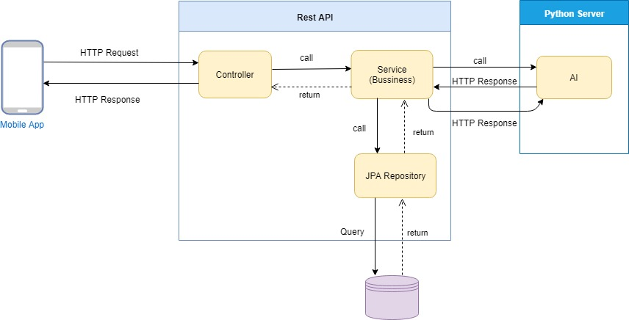

## 2.1 Web application architecture description

* In web application, the system is developed under MVC architecture style. We choose this architecture for Web application because of following advantages:
  + - Business code is separated with View and Controller that make easy to maintain and easy to understand.
    - Model is used to get and update data from database.
    - Controller takes request from web browser and makes a call to business logic layer.

**2.2 Mobile application architecture description**

* The activity in Mobile client act like a controller to redirect command from view in mobile.
* It takes HTTP Response from server and makes call HTTP Request.

**2.3 Python Server application**

* The Python server using Tensor flow, Dlib and open CV to recognize human face in pre trained data.
* It request Http post to server to return result after recognize.

**3.Component Diagram**  
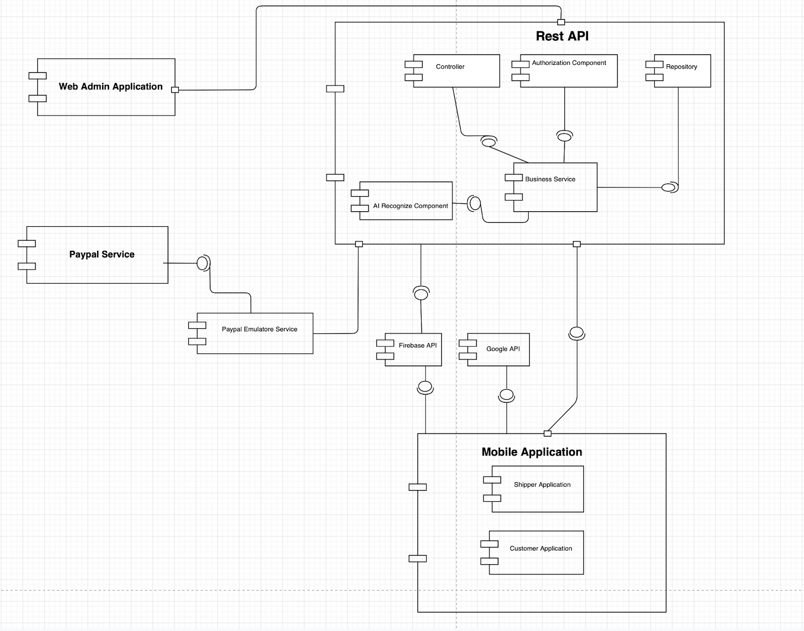

*Figure  Component Diagram*

|  |  |
| --- | --- |
| **Component Dictionary: Describe component** | |
| **Component Name** | **Description** |
| Shipper application | Component to handle request on Shipper application. |
| Customer application | Component to handle request on Customer application |
| Controller | Component to handle routing in Rest API. |
| Google API | Google Map API. |
| Firebase API | Firebase API. |
| Business Service | Component to handle Logic business service in Rest API. |
| Authorization | Component to handle security in Rest API ( Spring security). |
| Repository | Component to handle manage repo in Rest API. |
| AI Recognize | Component to handle Face Recognization. |
| Web Admin application | Component to handle view website admin over Rest API. |
| Paypal Service | Component of Paypal API service |
| Paypal Emulator | Component visual auto complete paypal Payment. |

*Table Component Dictionary*

# 4. Detail Description

## 4.1 Class Diagram

## https://lh5.googleusercontent.com/NwGlFnski8Bnbrv5Vs-dhu_weJDLFcINRw7OULA8U7BVPmW3IRsBdO1qGIEAAUtREYOToqElF6MIgyKcvvA2AI8iYXDbBJ1Ez_ASCSicb2i34yyMJn_1KcOp9Chn0qiT1EulW5Tz

*Figure  Class Diagram*

|  |  |
| --- | --- |
| **Class Dictionary** | |
| **Class Name** | **Description** |
| FRAccount | Contain account information |
| FRCity | Contain city information |
| FRDistrict | Contain district information |
| FROrder | Contain order information |
| FROrderDetail | Contain order detail information |
| FRPaymentInformation | Contain payment information |
| FRPaymentType | Contain payment type information |
| FRPriceLevel | Contain price level information |
| FRProduct | Contain product information |
| FRReceiveMember | Contain receive member information |
| FRRole | Contain role information |
| FRShipper | Contain shipper information |
| FRSource | Contain source information |
| FRStore | Contain store information |
| FRTransaction | Contain transaction information |

*Table Class Dictionary*

## 

## 4.2 Class Diagram Explanation

### 4.2.1 FRPaymentType

**Attribute**

|  |  |  |  |
| --- | --- | --- | --- |
| **Attribute** | **Type** | **Visibility** | **Description** |
| id | Integer | private | Unique identifier of payment types. |
| type | String | private | Type of payments |
| name | String | private | Display names of  payment types |
| description | String | private | Description of payment types |

**Method**

|  |  |  |  |
| --- | --- | --- | --- |
| **Method** | **Return type** | **Visibility** | **Description** |
| getter() | Attribute type | private | Get value of attributes |
| setter() | void | private | Set value for attributes |

### 4.2.2 FRPaymentInformation

**Attribute**

|  |  |  |  |
| --- | --- | --- | --- |
| **Attribute** | **Type** | **Visibility** | **Description** |
| id | Integer | private | Unique identifier of payment informations. |
| account | FRAccount | private | Account whose payment informations belong to |
| paymentType | FRPaymentType | private | Type of payment informations |
| username | String | private | Username of pay account. |
| password | String | private | Password of pay account. |

**Method**

|  |  |  |  |
| --- | --- | --- | --- |
| **Method** | **Return type** | **Visibility** | **Description** |
| getter() | String | public | Get value of attributes |
| setter() | void | public | Set value for attributes |

### 4.2.3 FRAccount

**Attribute**

|  |  |  |  |
| --- | --- | --- | --- |
| **Attribute** | **Type** | **Visibility** | **Description** |
| id | Integer | private | Unique identifier of accounts |
| phone | String | private | Phone number of accounts |
| role | FRRole | private | Role of accounts |
| password | String | private | Password of accounts |
| name | String | private | Full name. |
| email | String | private | Email of account. |
| extraPoint | Integer | private | Extra point of account. |
| reportPoint | Integer | private | Report point of account |
| userImage | byte array | private | Image of account. |
| natId | String | private | Nation Id number |
| natDate | Long | private | Represent Nation Id’s date-of-issue |
| dob | Long | private | Represent birthdate |
| createTime | Long | private | Create time of accounts |
| updateTime | Long | private | Last update time of accounts |
| deleteTime | Long | private | Deactivate time of accounts |
| note | String | private | Note |
| status | Integer | private | Status of accounts |
| editor | FRAccount | private | Id of editor’s accounts |
| avatar | byte array | private | Avatar of account. |

**Method**

|  |  |  |  |
| --- | --- | --- | --- |
| **Method** | **Return type** | **Visibility** | **Description** |
| getter() | Attribute type | public | Get value of attributes |
| setter() | void | public | Set value for attributes |

### 4.2.4 FRCity

**Attribute**

|  |  |  |  |
| --- | --- | --- | --- |
| **Attribute** | **Type** | **Visibility** | **Description** |
| id | Integer | private | Unique identifier of city. |
| name | String | private | Name of city. |
| postalCode | String | private | Postal code of city |

**Method**

|  |  |  |  |
| --- | --- | --- | --- |
| **Method** | **Return type** | **Visibility** | **Description** |
| getter() | String | public | Get value of attributes |
| setter() | void | public | Set value for attributes |

### 4.2.5 FRDistrict

**Attribute**

|  |  |  |  |
| --- | --- | --- | --- |
| **Attribute** | **Type** | **Visibility** | **Description** |
| id | Integer | private | Unique identifier of districts |
| name | String | private | Name of districts |
| city | FRCity | private | Cities which districts are in |

**Method**

|  |  |  |  |
| --- | --- | --- | --- |
| **Method** | **Return type** | **Visibility** | **Description** |
| getter() | String | public | Get value of attributes |
| setter() | void | public | Set value for attributes |

### 4.2.6 FROrder

**Attribute**

|  |  |  |  |
| --- | --- | --- | --- |
| **Attribute** | **Type** | **Visibility** | **Description** |
| id | Integer | private | Unique identifier of orders |
| account | FRAccount | private | Buyers of orders |
| shipper | FRShipper | private | Shipper of orders |
| buyer_face | byte array | private | Receiver’s faces |
| bill | String | private | Image of bills |
| orderCode | String | private | Code of orders |
| totalPrice | Double | private | Price of products |
| buyTime | Long | private | Time which bills were created |
| receiveTime | Long | private | Receive time of orders |
| shipper_earn | Double | private | Total shipping cost |
| priceLevel | Double | private | Percentages of shipper earning from shipping cost |
| shipAddress | String | private | Location of buyer in text |
| longitude | Double | private | Location of buyer(longitude) |
| latitude | Double | private | Location of buyer(latitude) |
| customer_description | String | private | Description for product |
| create_time | Long | private | Create time |
| update_time | Long | private | Update time |
| delete_time | Long | private | Deactivate time |
| editor | FRAccount | private | Id of editor’s accounts |
| note | String | private | Note of orders |
| status | Integer | private | Status of orders |
| buyerToken | String | private | Customers’ device token |
| shipperToken | String | private | Shippers’ device token |
| rating | Integer | private | Customer’s rating for shipper |

**Method**

|  |  |  |  |
| --- | --- | --- | --- |
| **Method** | **Return type** | **Visibility** | **Description** |
| getter() | String | public | Get value of attributes |
| setter() | void | public | Set value for attributes |

### 4.2.7 FROrderDetail

**Attribute**

|  |  |  |  |
| --- | --- | --- | --- |
| **Attribute** | **Type** | **Visibility** | **Description** |
| id | Integer | private | Unique identifier of order details |
| order | FROrder | private | Orders which details belong to |
| product | FRProduct | private | Ordered products |
| unitPrice | Double | private | Price of products when orders were created |
| quantity | Integer | private | Ordered quantity of product. |

**Method**

|  |  |  |  |
| --- | --- | --- | --- |
| **Method** | **Return type** | **Visibility** | **Description** |
| getter() | String | public | Get value of attributes |
| setter() | void | public | Set value for attributes |

### 4.2.8 FRPriceLevel

**Attribute**

|  |  |  |  |
| --- | --- | --- | --- |
| **Attribute** | **Type** | **Visibility** | **Description** |
| id | Integer | private | Unique identifier of price levels |
| levelName | String | private | Name of price levels |
| description | String | private | Description of price levels |
| price | Double | private | Percentage for shipper in shipping fee |
| orderReq | Integer | private | Number of success order required for shipper to be promoted to this level |
| rateReq | Double | private | Average rating required for shipper to be promoted to this level |
| nextLevel | FRPriceLevel | private | Next level shipper can be promoted to |

**Method**

|  |  |  |  |
| --- | --- | --- | --- |
| **Method** | **Return type** | **Visibility** | **Description** |
| getter() | String | public | Get value of attributes |
| setter() | void | public | Set value for attributes |

### 4.2.9 FRProduct

**Attribute**

|  |  |  |  |
| --- | --- | --- | --- |
| **Attribute** | **Type** | **Visibility** | **Description** |
| id | Integer | private | Unique identifier of products |
| store | FRStore | private | Stores in which products belong |
| price | Double | private | Current price of products |
| productName | String | private | Name of products |
| productImage | byte array | private | Image of products |
| description | String | private | Description for products |
| createTime | Long | private | Create time of products |
| updateTime | Long | private | Update time of products |
| deleteTime | Long | private | Deactivate time of products |
| note | String | private | Note of products |
| status | Integer | private | Status of products |
| editor | FRAccount | private | Admin who edited  products |

**Method**

|  |  |  |  |
| --- | --- | --- | --- |
| **Method** | **Return type** | **Visibility** | **Description** |
| getter() | String | private | Get value of attributes |
| setter() | void | private | Set value for attributes |

### 4.2.11 FRRole

**Attribute**

|  |  |  |  |
| --- | --- | --- | --- |
| **Attribute** | **Type** | **Visibility** | **Description** |
| id | Integer | private | Unique identifier of roles |
| name | Integer | private | Name of roles |
| description | Integer | private | Description of roles |

**Method**

|  |  |  |  |
| --- | --- | --- | --- |
| **Method** | **Return type** | **Visibility** | **Description** |
| getter() | String | public | Get value of attributes |
| setter() | void | public | Set value for attributes |

### 4.2.13 FRShipper

**Attribute**

|  |  |  |  |
| --- | --- | --- | --- |
| **Attribute** | **Type** | **Visibility** | **Description** |
| id | Integer | private | Unique identifier of shipper. |
| introduce | String | private | Introduce of shipper. |
| sumRevenue | Integer | private | Sum Revenue of shipper |
| natIdFrontImage | byte array | private | Front image of Nation Id Cards |
| natIdBackImage | byte array | private | Back image of Nation Id Cards |
| bikeRegId | String | private | Bike Registrations’ Number |
| bikeRegDate | Long | private | Date of Bike Registration Card |
| bikeRegFront | byte array | private | Front image of Bike Id Card |
| bikeRegBack | byte array | private | Back image of Bike Id Card |
| account | FRAccount | private | Linked to FRAccount |
| source | FRSource | private | Reason shippers know this app |
| priceLevel | FRPriceLevel | private | Shippers’ price level. |
| rating | Double | private | Rating of shippers |
| ratingCount | Integer | private | Number of accounts rating for shippers |
| orderCount | Integer | private | Number of successfully orders |

**Method**

|  |  |  |  |
| --- | --- | --- | --- |
| **Method** | **Return type** | **Visibility** | **Description** |
| getter() | String | public | Get value of attributes |
| setter() | void | public | Set value for attributes |

### 4.2.14 FRSource

**Attribute**

|  |  |  |  |
| --- | --- | --- | --- |
| **Attribute** | **Type** | **Visibility** | **Description** |
| id | Integer | private | Unique identifier of sources |
| name | String | private | Display name of sources |
| description | String | private | Description of sources |

**Method**

|  |  |  |  |
| --- | --- | --- | --- |
| **Method** | **Return type** | **Visibility** | **Description** |
| getter() | String | public | Get value of attributes |
| setter() | void | public | Set value for attributes |

### 4.2.15 FRStore

**Attribute**

|  |  |  |  |
| --- | --- | --- | --- |
| **Attribute** | **Type** | **Visibility** | **Description** |
| id | Integer | private | Unique identifier of stores |
| storeName | String | private | Name of stores |
| address | String | private | Address of stores |
| district | FRDistrict | private | District where stores are |
| longitude | Double | private | Longitude of stores |
| latitude | Double | private | Latitude of stores |
| storeImage | byte array | private | Image of stores |
| phone | String | private | Phone number of stores |
| create_time | Long | private | Create time of stores |
| update_time | Long | private | Update time of stores |
| delete_time | Long | private | Deactivate time of stores |
| note | String | private | Note of stores |
| status | Integer | private | Status of stores |
| editor | FRAccount | private | Admin who edited stores |

**Method**

|  |  |  |  |
| --- | --- | --- | --- |
| **Method** | **Return type** | **Visibility** | **Description** |
| getter() | String | public | Get value of attributes |
| setter() | void | public | Set value for attributes |

### 4.2.16 FRReceiveMember

**Attribute**

|  |  |  |  |
| --- | --- | --- | --- |
| **Attribute** | **Type** | **Visibility** | **Description** |
| id | Integer | private | Unique identifier of receive members |
| name | String | private | Name of receive members |
| face | byte array | private | Face of receive members |

**Method**

|  |  |  |  |
| --- | --- | --- | --- |
| **Method** | **Return type** | **Visibility** | **Description** |
| getter() | String | public | Get value of attributes |
| setter() | void | private | Set value for attributes |

### 4.2.16 FRTransaction

**Attribute**

|  |  |  |  |
| --- | --- | --- | --- |
| **Attribute** | **Type** | **Visibility** | **Description** |
| id | Integer | private | Unique identifier of transactions |
| payId | String | private | payId of transaction |
| amount | Double | private | Amount of cash transferred |
| time | Long | private | Time at which transactions completed |

**Method**

|  |  |  |  |
| --- | --- | --- | --- |
| **Method** | **Return type** | **Visibility** | **Description** |
| getter() | String | public | Get value of attributes |
| setter() | void | private | Set value for attributes |

**4.3 Interaction Diagram**

**4.3.1 <Customers>**

**4.3.1.1 <Customer> Login**

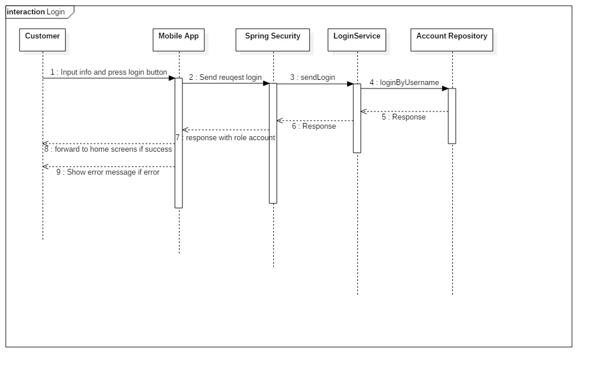

Figure:  <Customer> Login

**4.3.1.2 <Customer> Register**

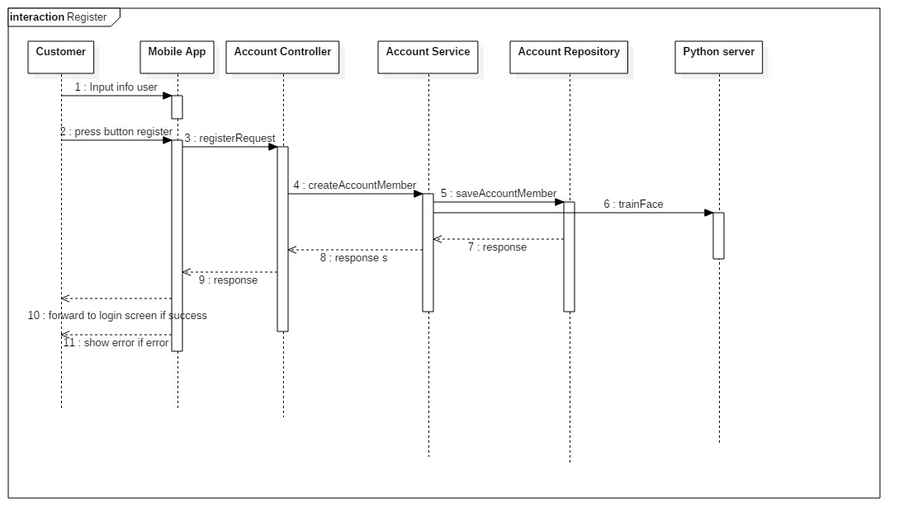

Figure:  <Customer> Register

**4.3.1.3 <Customer> View product list**

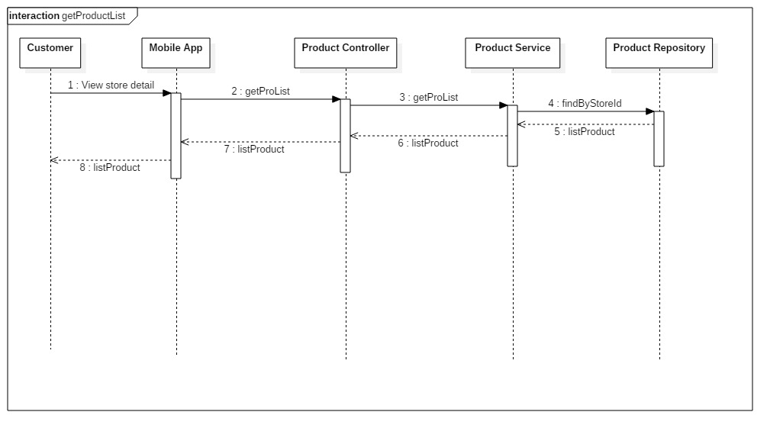

Figure:  <Customer> View product list

**4.3.1.4 <Customer> Create Order**

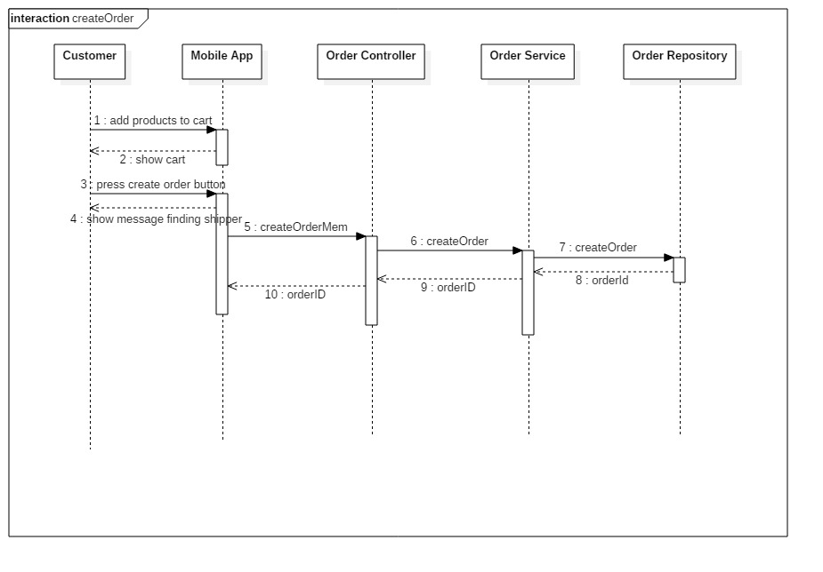

Figure:  <Customer> Create Order

**4.3.1.5 <Customer>View order history**

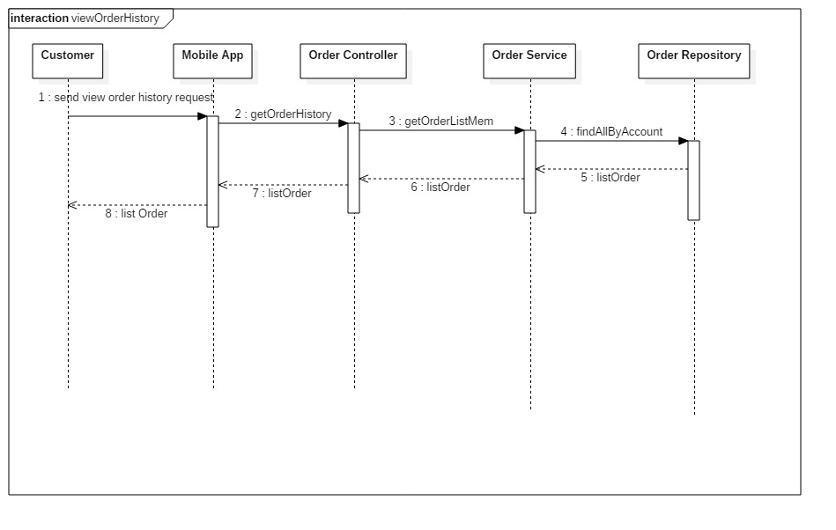

Figure:  <Customer> View order history

**4.3.1.6 <Customer> View order detail**

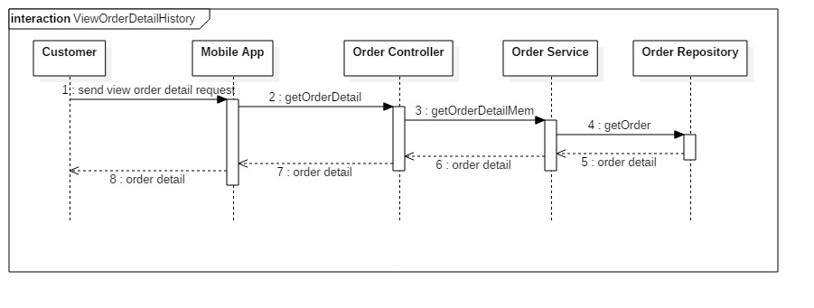

Figure:  <Customer> View order detail

**4.3.1.7 <Customer> Edit profile**

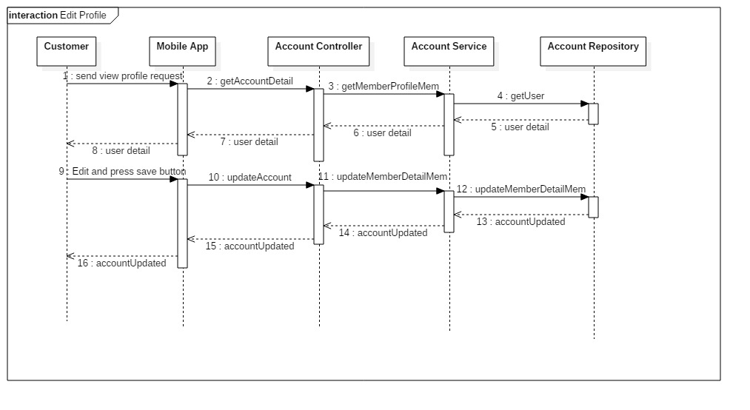

Figure:  <Customer> Edit profile

**4.3.2 <Shipper>**

**4.3.2.1 <Shipper> Take order**

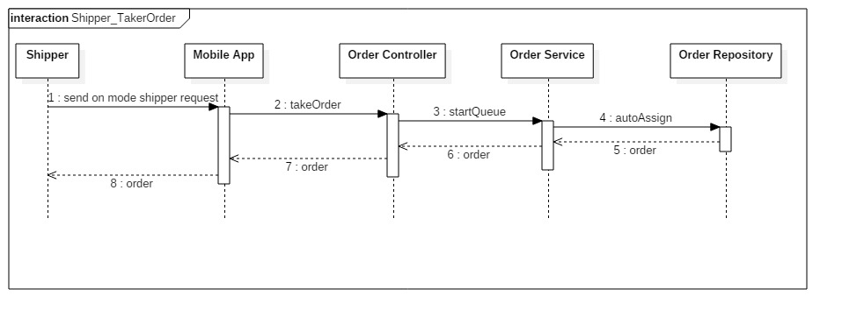

Figure:  <Shipper> Take Order

**4.3.2.2 <Shipper> View profile**

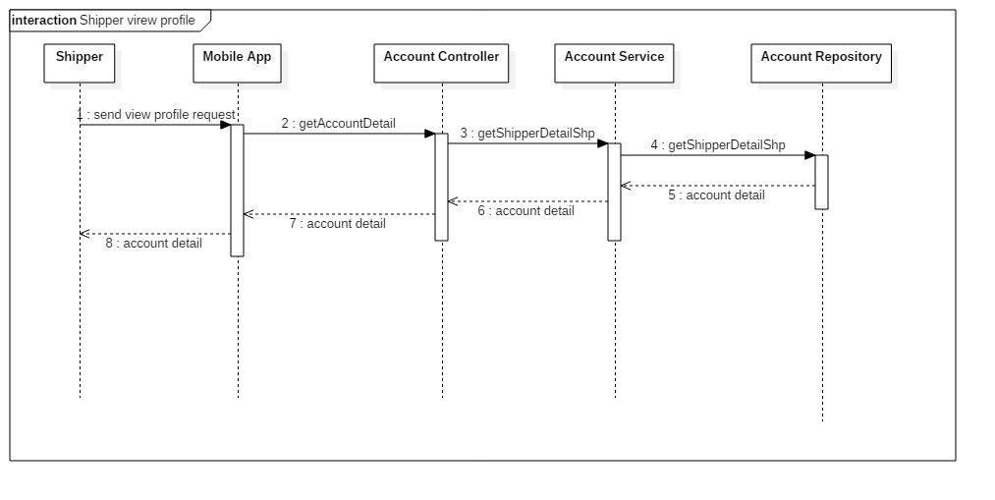

Figure:  <Shipper> View profile

**4.3.2.3 <Shipper> Take bill**

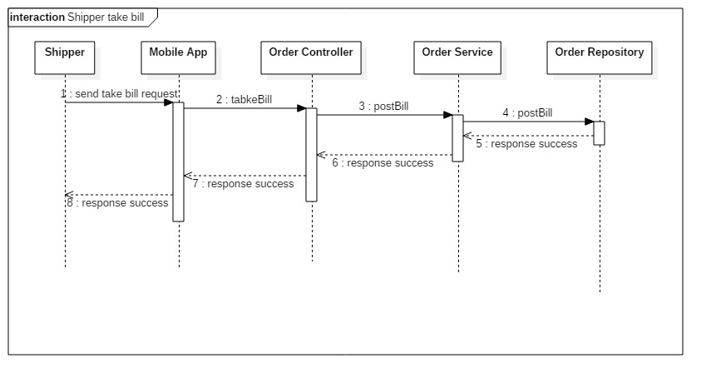

Figure:  <Shipper> Take bill

**4.3.2.4 <Shipper> Check out**

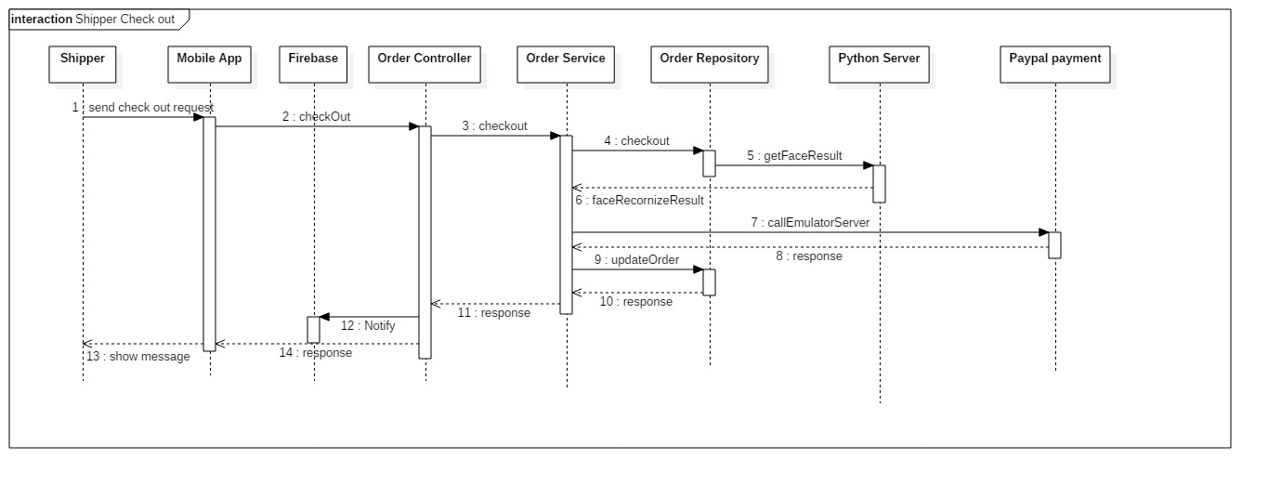

Figure:  <Shipper> Check out

**4.3.3 <Admin>**

**4.3.3.1  <Admin> View list of Customers**

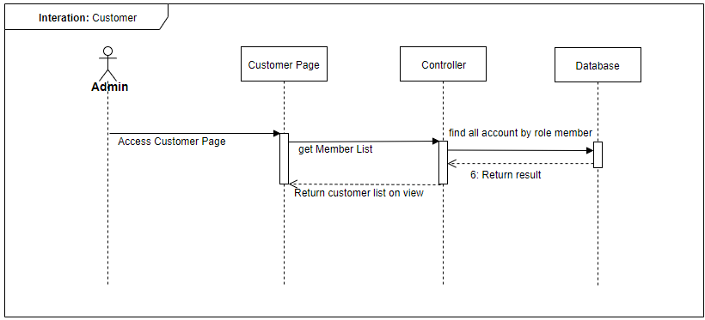

Figure:  <Admin> View list of Customers

**4.3.3.2  <Admin> View detail of Customers**

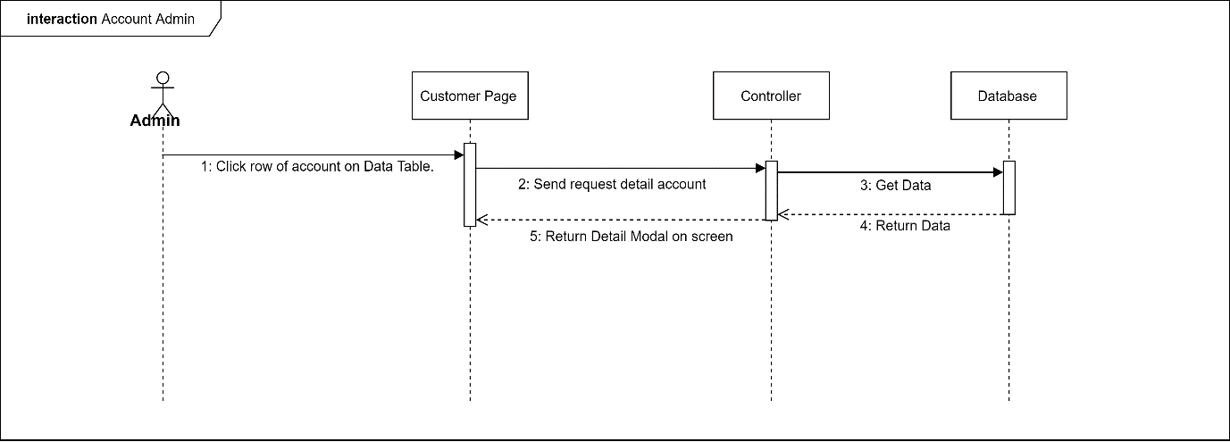

Figure:  <Admin> View detail of Customers

**4.3.3.3  <Admin> Edit Customers**

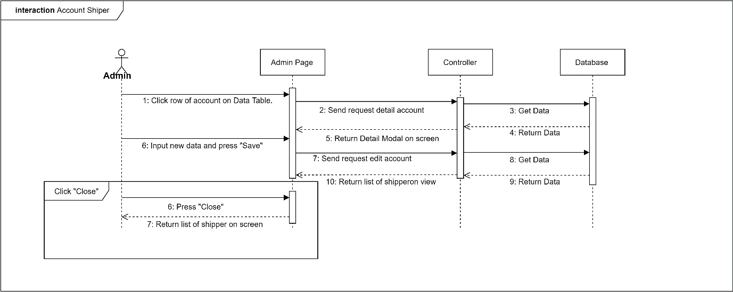

Figure:  <Admin> Edit Customers

**4.3.3.4  <Admin> View list of Shippers**

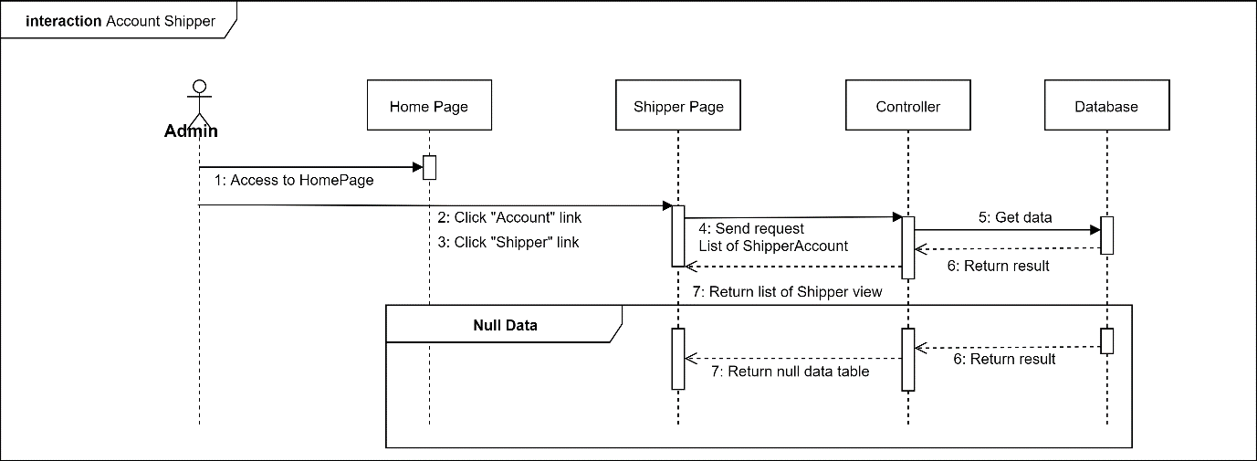

Figure:  <Admin> View list of Shippers

**4.3.3.5  <Admin> View detail of Shippers**

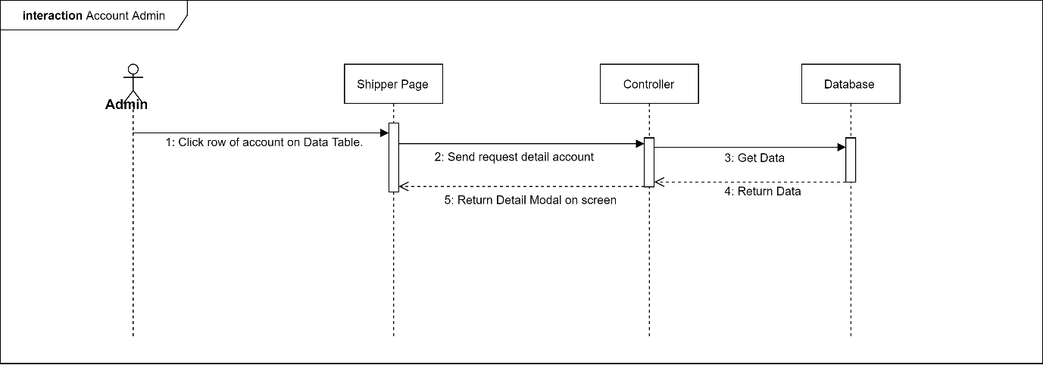

Figure:  <Admin> View detail of Shippers

**4.3.3.6  <Admin> Add new Shippers**

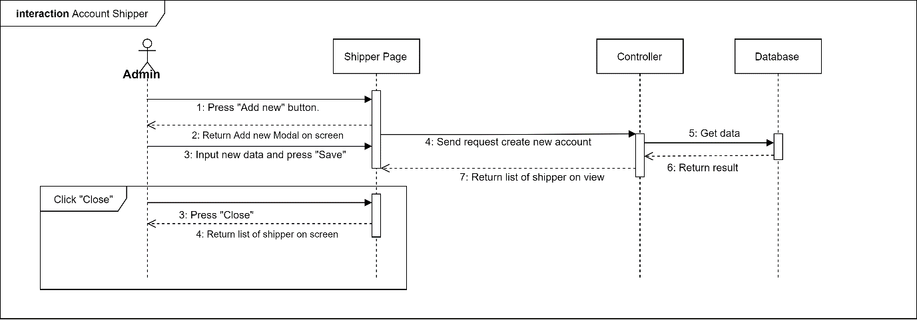

Figure:  <Admin> Add new Shippers

**4.3.3.7  <Admin> Edit Shippers**



Figure:  <Admin> Edit Shippers

**4.3.3.8  <Admin> View list of Admins**

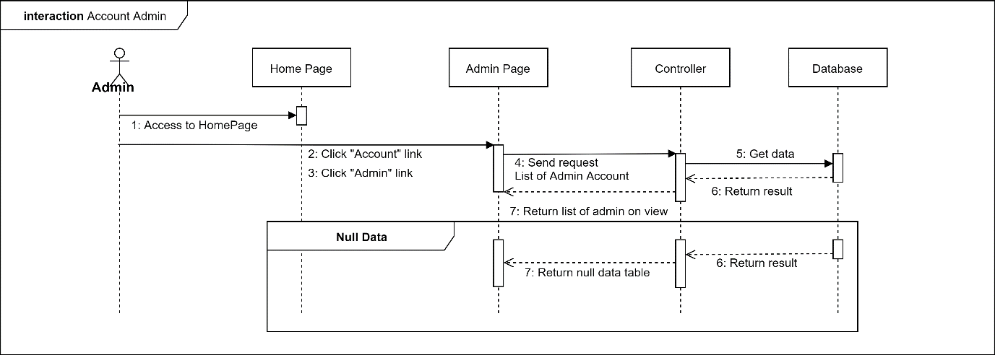

Figure:  <Admin> View list of Admins

**4.3.3.9  <Admin> View detail of Admins**

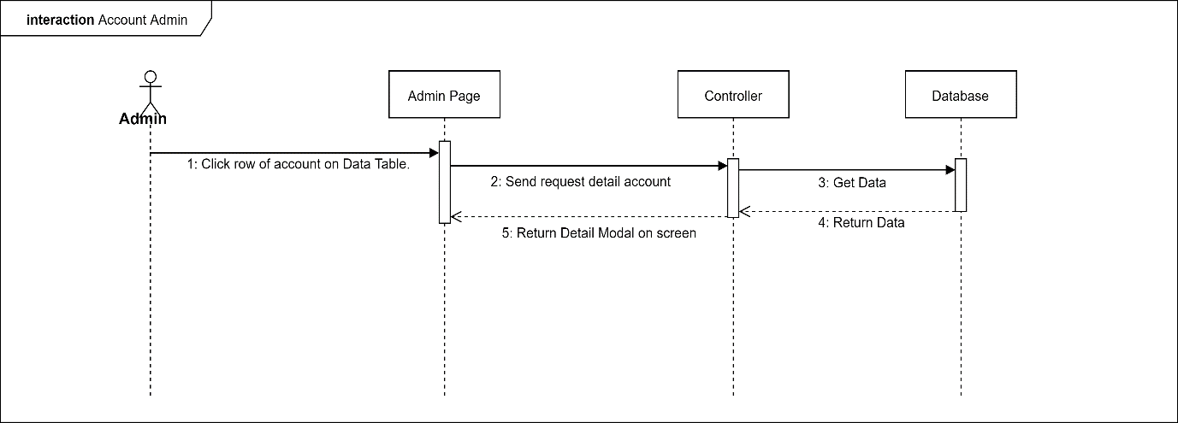

Figure:  <Admin> View detail of Admins

**4.3.3.10  <Admin> Add new Admins**

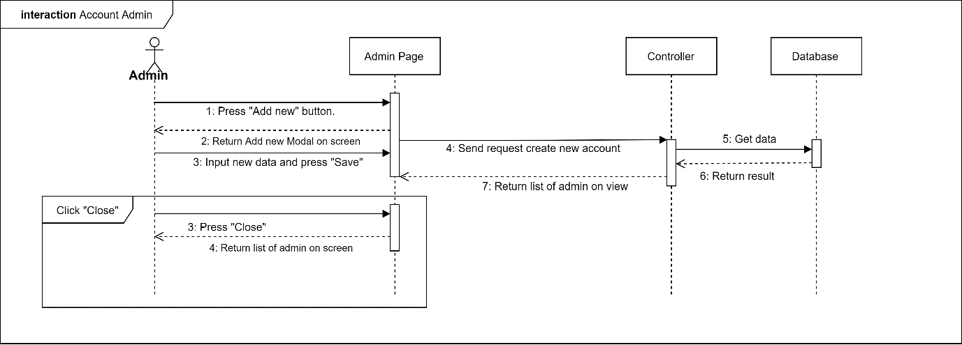

Figure:  <Admin> Add new Admins

**4.3.3.11  <Admin> Edit Admins**

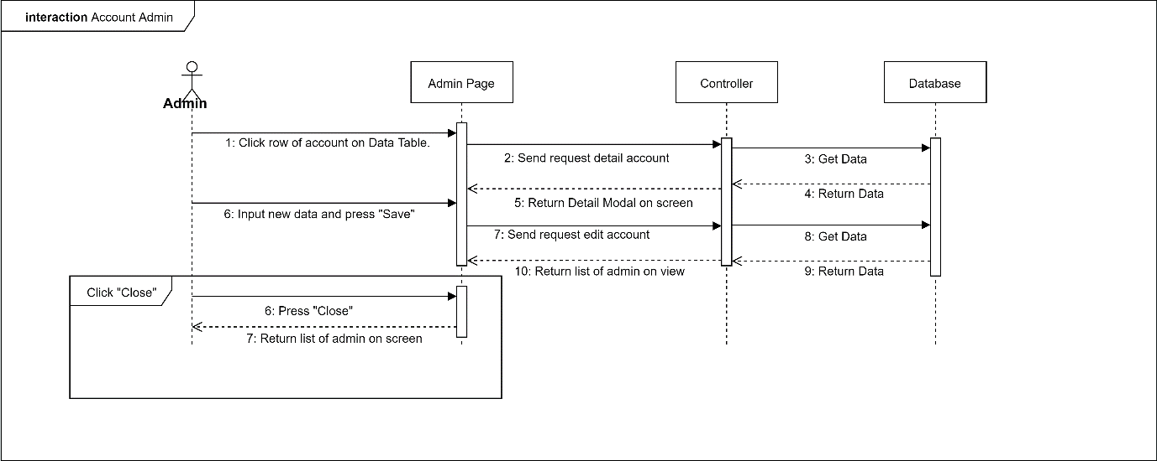

Figure:  <Admin> Edit Admins

**4.3.3.12  <Admin> View list of Stores**

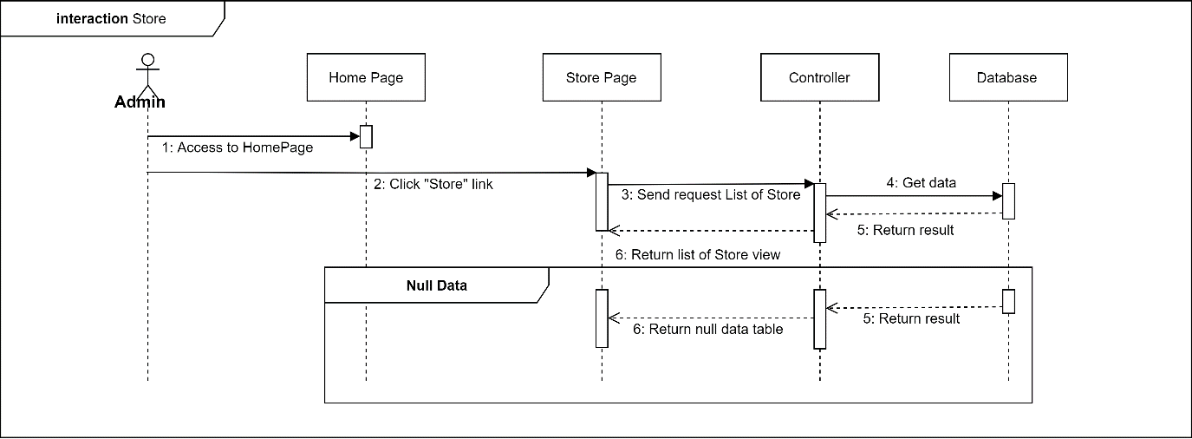

Figure:  <Admin> View list of Stores

**4.3.3.13  <Admin> View detail of Stores**

### https://lh4.googleusercontent.com/IExCvJYoCNwdDJgE0P9G_sKeST_0AmHak7ogOXoZTdzjToUXOODoJL2hn6SY1mz6owdvfu8mbC6ff0917yC3zFvuwnaW_irmXdRLMFgN1Yoec-lSjKuaDdAFpFifvZVH1XSeLsI7

Figure:  <Admin> View detail of Stores

**4.3.3.14  <Admin> Add new Stores**

### https://lh5.googleusercontent.com/2n_b81dQYK83mRieLL1DBAmgmgQLxpKX6TZzJu31sUlW75Tr2H-95QqkoohVAIakbKDpuwopo_94H4416BJdaqkgwWI8oAYr8qxhKf-WWLmUKArfLigPu17LHmkxZ3qNr07HeQYL

Figure:  <Admin> Add new Stores

**4.3.3.15  <Admin> Edit Stores**

### https://lh4.googleusercontent.com/5eTLIz-3EfwuA1JyIz6Wr0p0Qa0raQmerwZ7ies5hfj3fyXsypko2bKoaK7UWYiD4t2jmpoMrJuJcZLe5G2-1cOrno1BJ-4nl3oFQF5vVq1tAyaQ0Idk60_HfBrUndTIvSpkIh9V

Figure:  <Admin> Edit Stores

**4.3.3.16  <Admin> View list of Products**

### https://lh3.googleusercontent.com/hXjpyOVLTLaoyQOCbUxUPXBaQMa3kcHP8iMSy8LjA2jm_HWgggDcjko5i-1lvXKJM3xkU0FlbqFMlKEvA_8k9doly7vFt5nPTPviW7VIkujL4w2t0lg60XptJzdjGQY5O8nL645Q

Figure:  <Admin> View list of Products

**4.3.3.17  <Admin> View detail of Products**

### https://lh3.googleusercontent.com/-7nkKVbfdGb7UenMXcKnx9bhAXuK6XDiC-r8VwIdMmlSRI9Ja2qg_GwbFx8_URw5NqwU5v9RmInZ7x32m3z_fWXFsmdi5dX6ffmvtBraJscpiVDL6p1_arQxDD6YufBuAGxoR9x2

Figure:  <Admin> View detail of Products

**4.3.3.18  <Admin> Add new Products**

### https://lh3.googleusercontent.com/DGiXecW40v_hw2roPM8o53dbu3xojvduBFUr7WVSKGOWHRpLYieSoQOFKdJRaMjIzUwgyQcG2dgq9RjAp_5bA1Cm8-CV3CLWWcjEnGay4NR2M3eAH-oi1ERwaXQUSfuOIS7rSIvx

Figure:  <Admin> Add new Products

**4.3.3.19  <Admin> Edit Products**

### https://lh6.googleusercontent.com/_MMmTWbYJZ8cIGAjjqq4FRh3xJFTe7Ly9VyRs_YHwBUMzR0ZsdhxOoQC0PgrN9XErToU6CCSUvgGhPR3jWjWzDCLpAr8NJ8Ia79IwexBUqhy3Z1iQDV6z1SPFxBz7IahgtUuPe0S

Figure:  <Admin>Edit Products

**4.3.3.20  <Admin> View list of Orders**

### https://lh4.googleusercontent.com/vfe4S6tM-GEnuWGiUaL5wuJF-k724V9SNkXf_-plzqtG9yzmikTWfyp_Skbq4CyGiRSQHbYeNQDNQWG_7y4q9_86VadrLdXiYcG8Jfu9WzAUj8EFj76P4pnb76GCb_RfkUghIW3G

Figure:  <Admin> View list of Orders

**4.3.3.21  <Admin> View detail of Orders**

### https://lh6.googleusercontent.com/FLICdsK_qlPZoMl-fIF26AUykNPy71fzKQemvALRLvIXSBriJWnTMwzZpjjTB3mOD44BIOdd75jlQfcRTxdqiaWHGhSbbxe52XhQqV9m-9PvtjSN1Q9c8rZbvxO5jecajbWiRztV

Figure:  <Admin> View detail of Orders

**4.3.3.22  <Admin> Edit Orders**

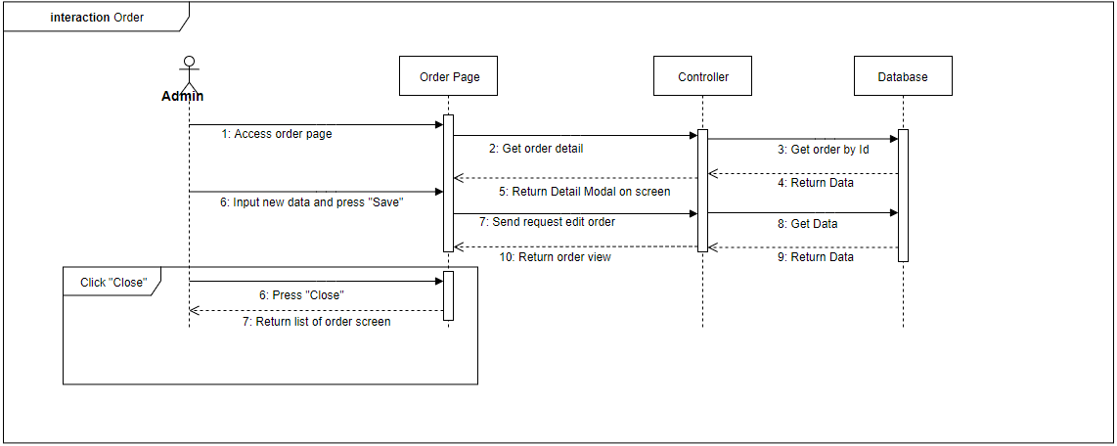

Figure:  <Admin> Edit Orders

**4.3.3.22  <Admin> Edit Profile**

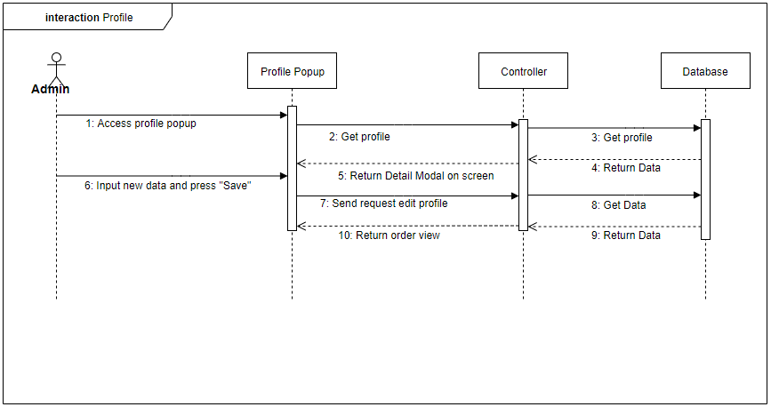

Figure:  <Admin> Edit Profile

**4.3.3.23  <Admin> View Reports**

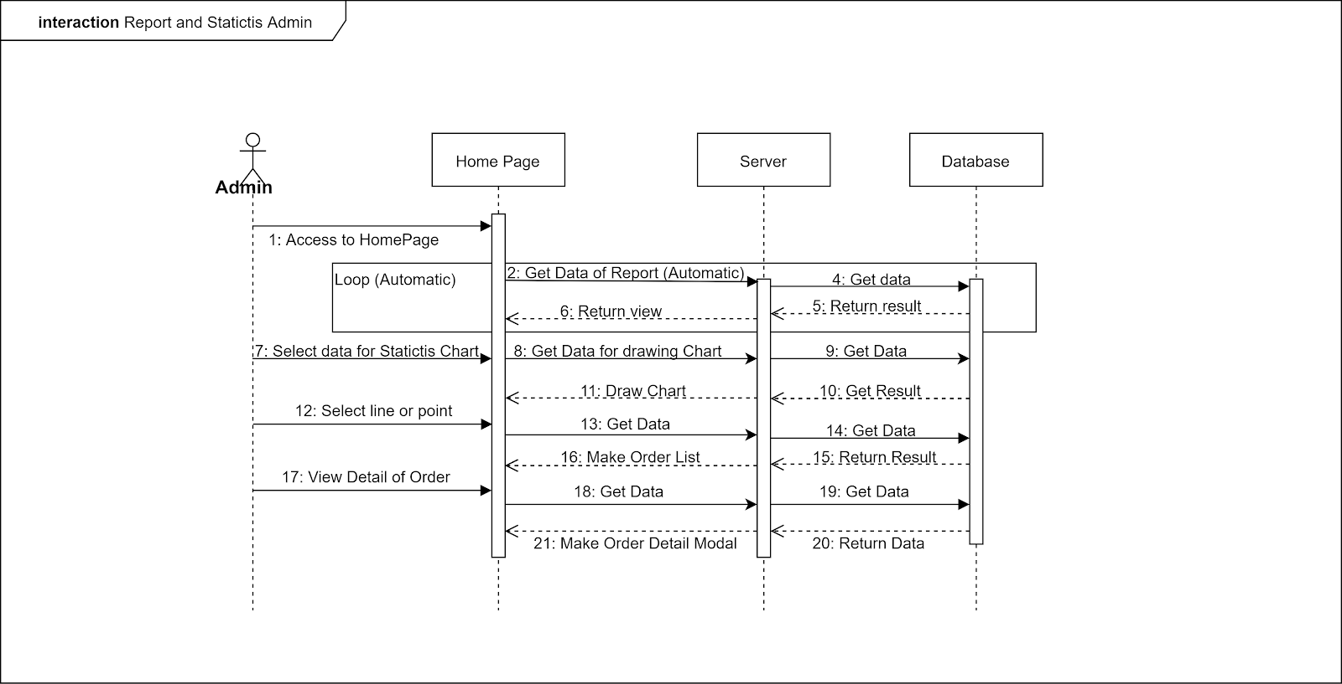

Figure:  <Admin> View Reports

# 5. Interface

## 5.1 Customer Mobile Application

1. Login

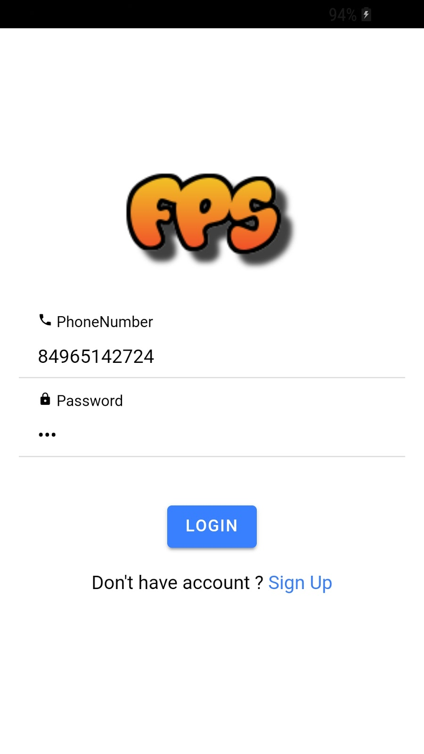

1. Register

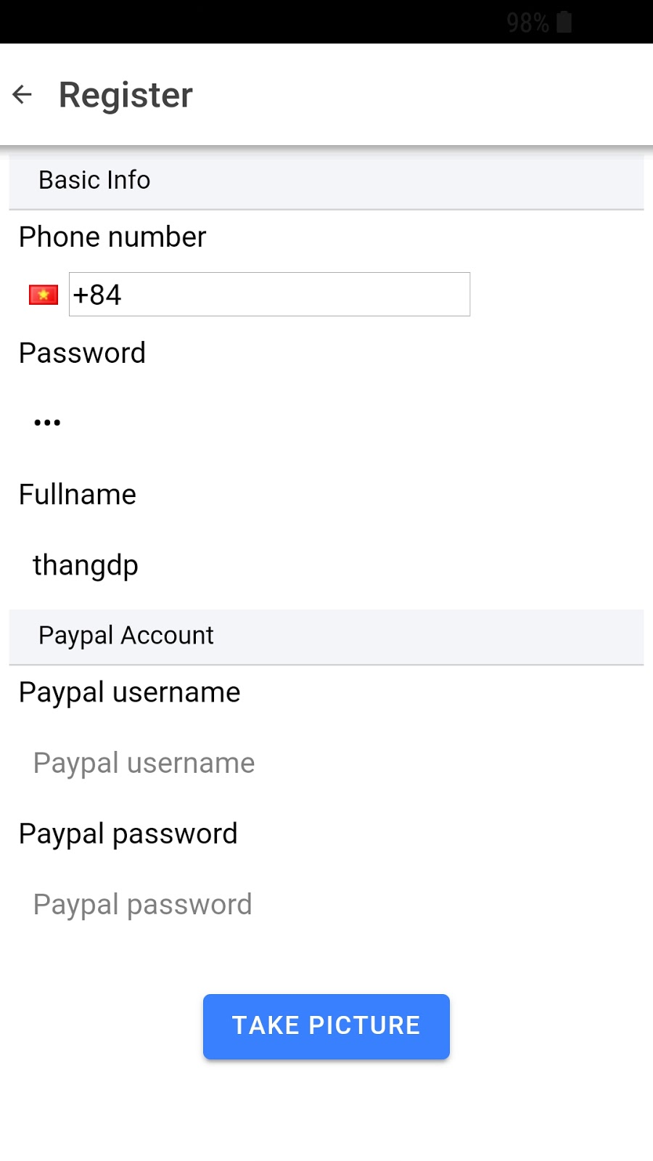

1. Edit Profile

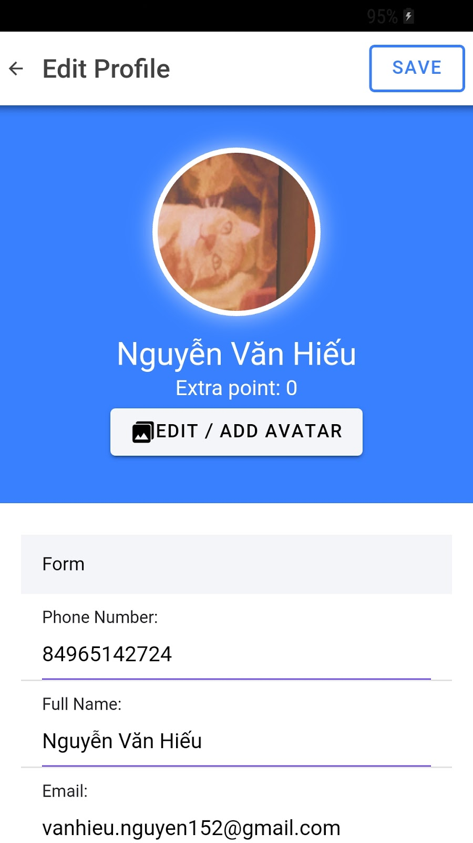 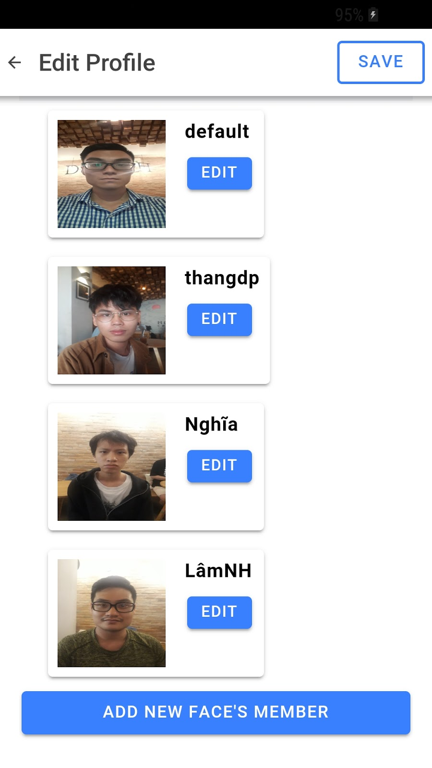

1. Edit Member Receive

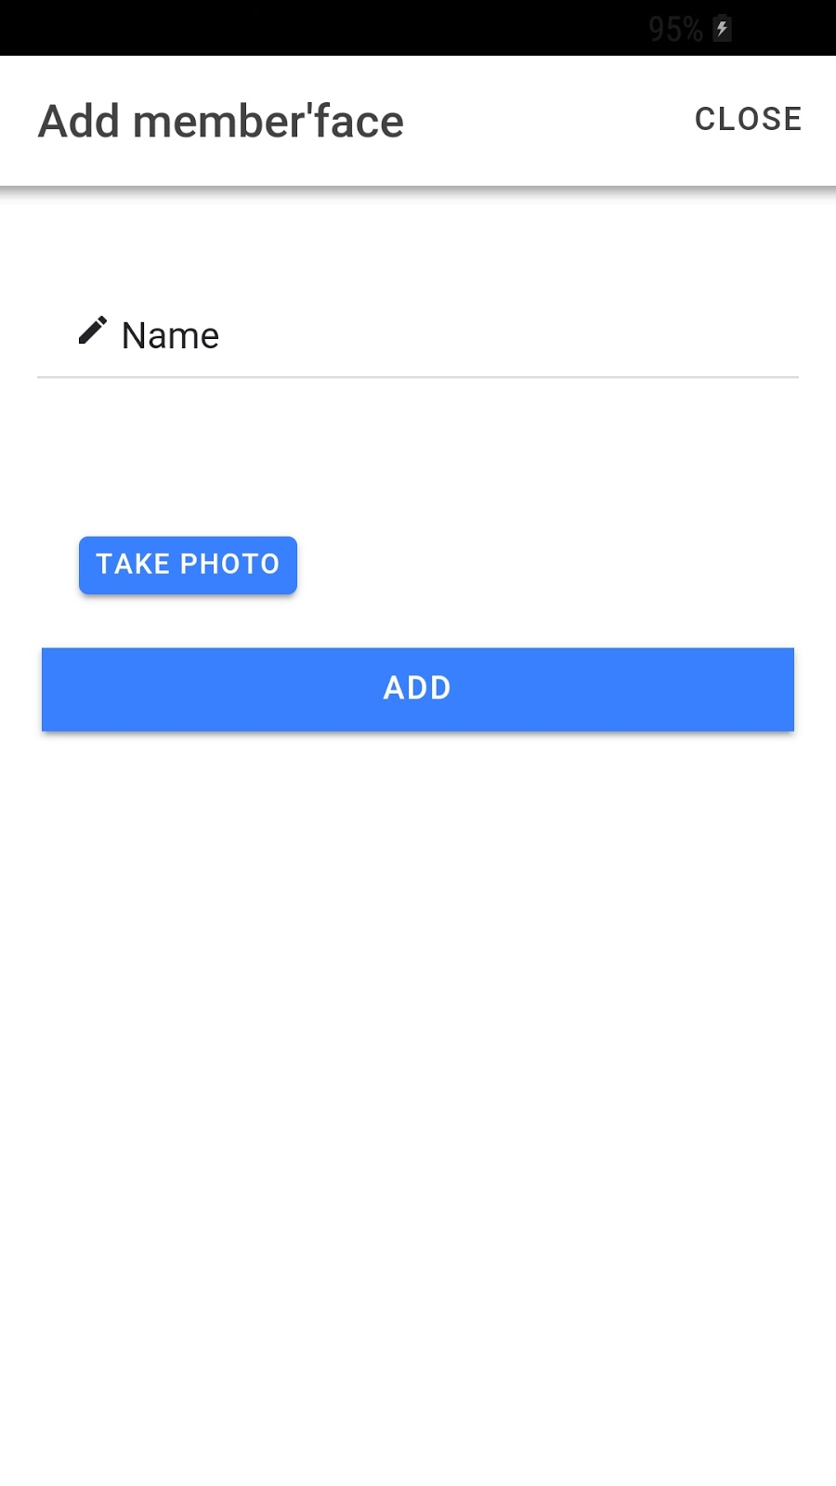

1. Home

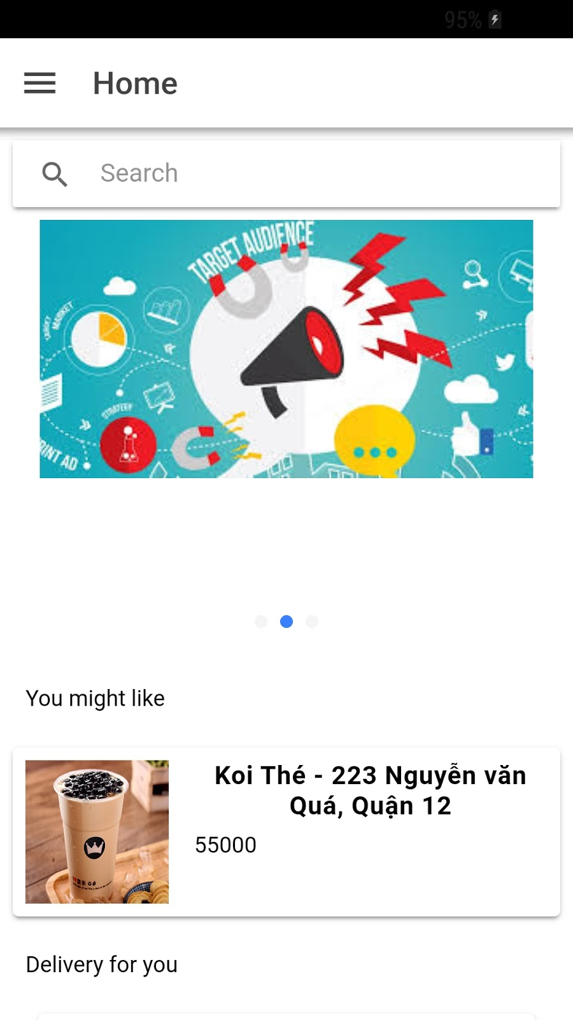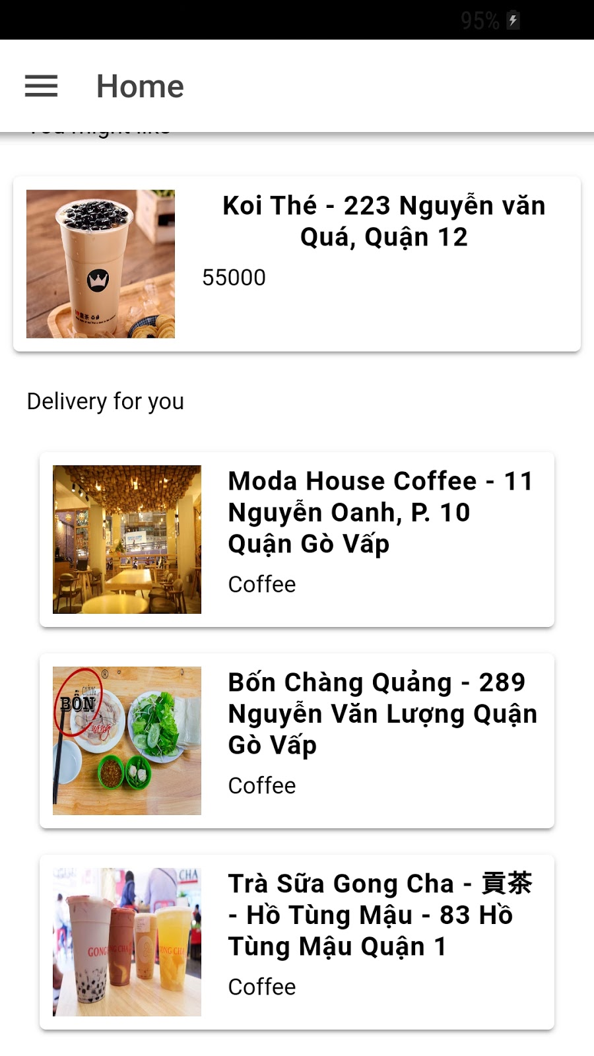

1. Book order

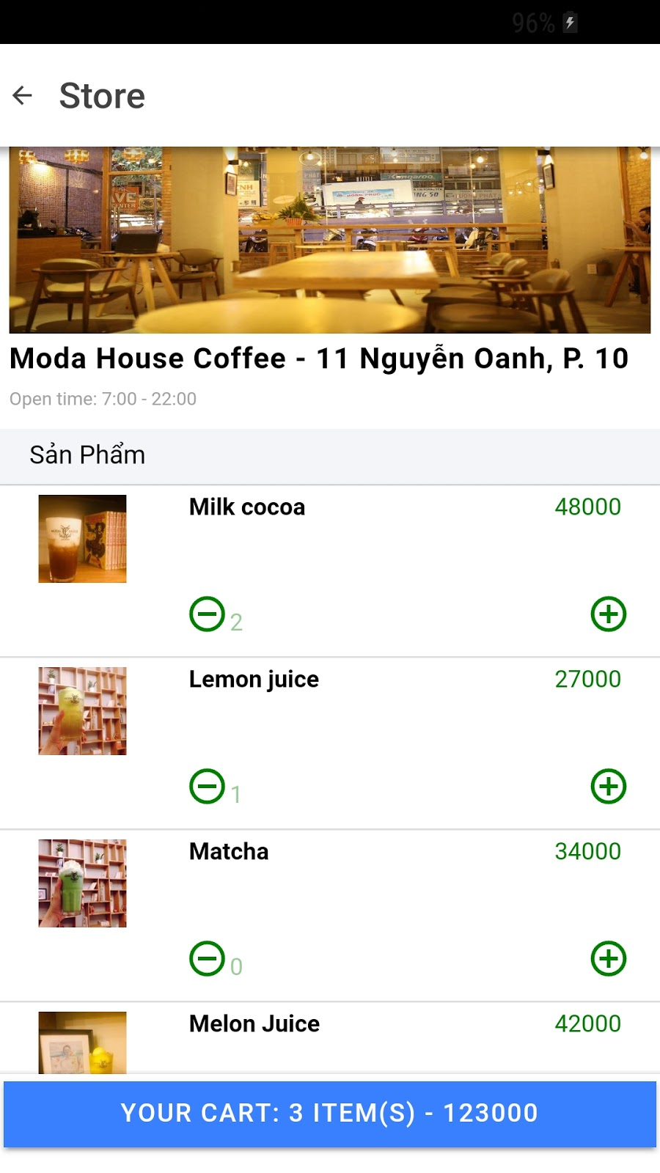

1. Order Rating

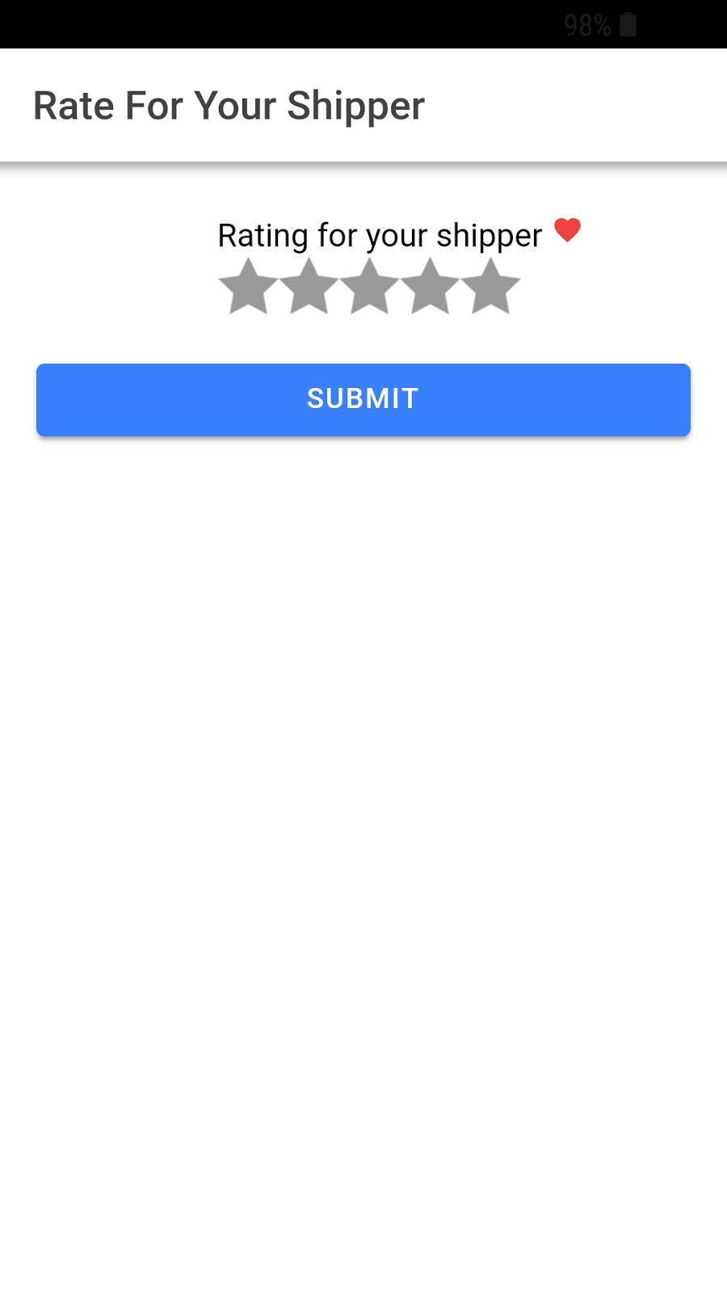

1. Order History

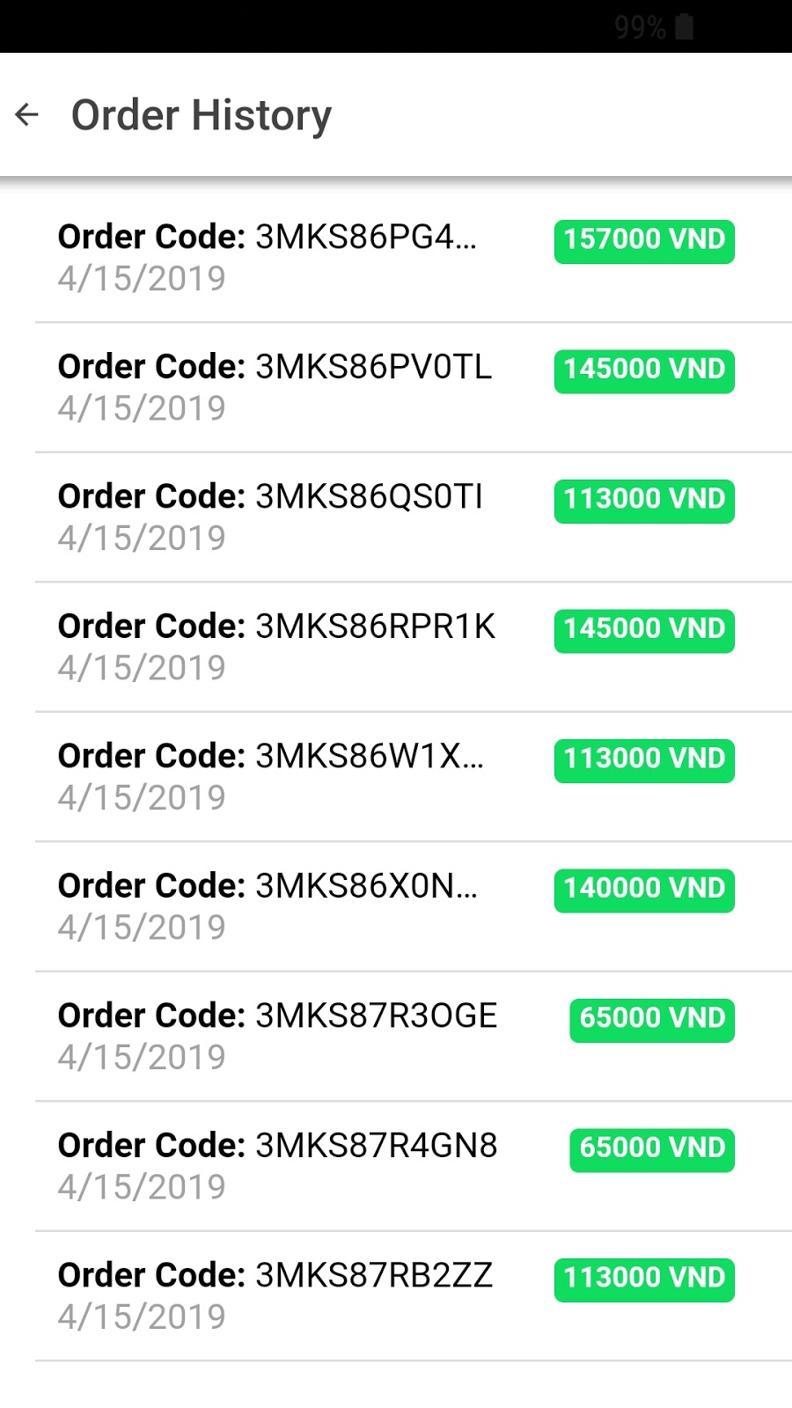  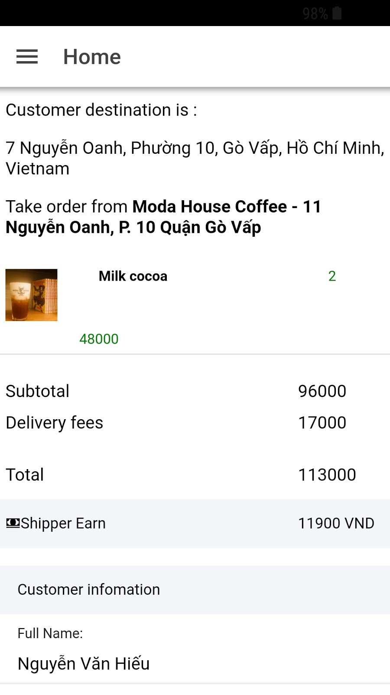

## 5.2 Shipper Mobile Application

1. Take Order

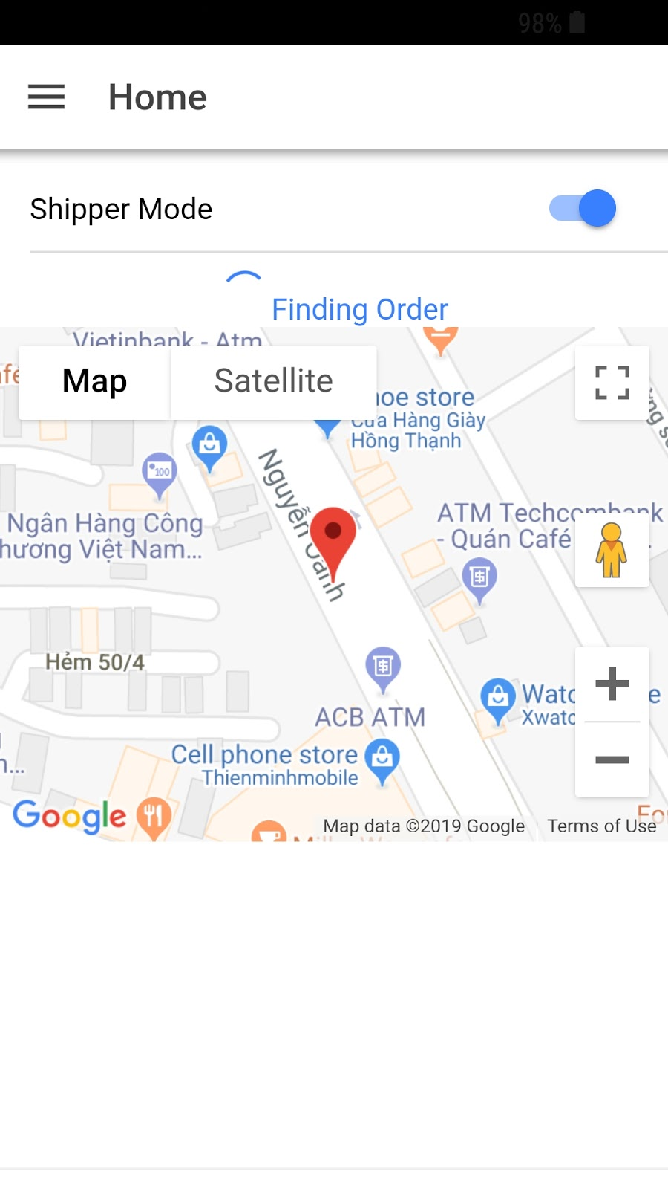

1. Order Detail

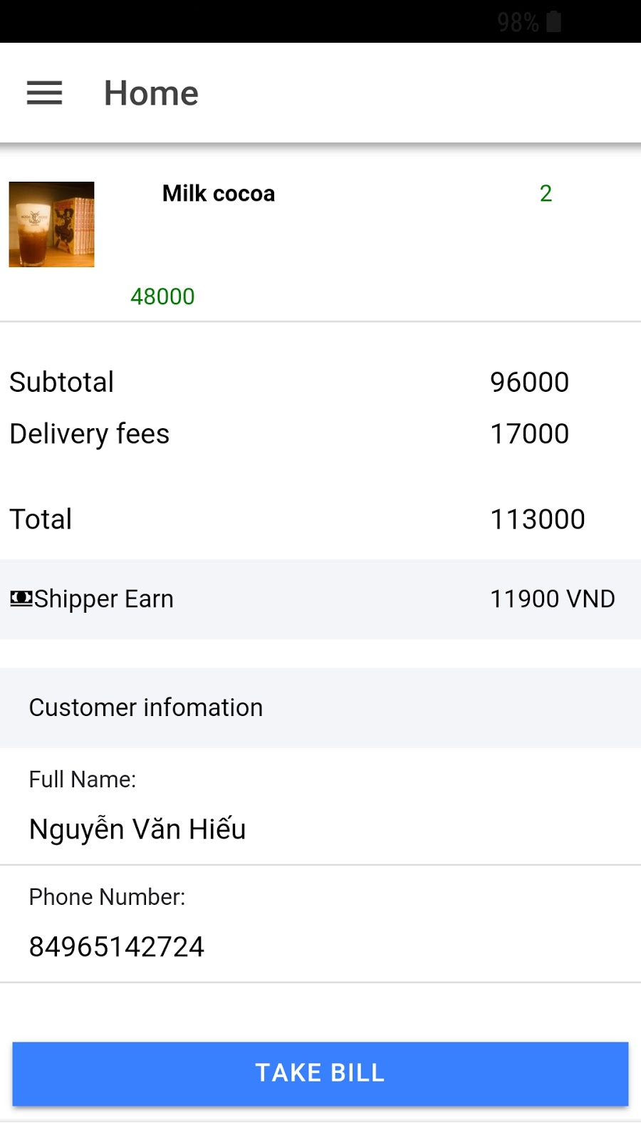

1. Routing

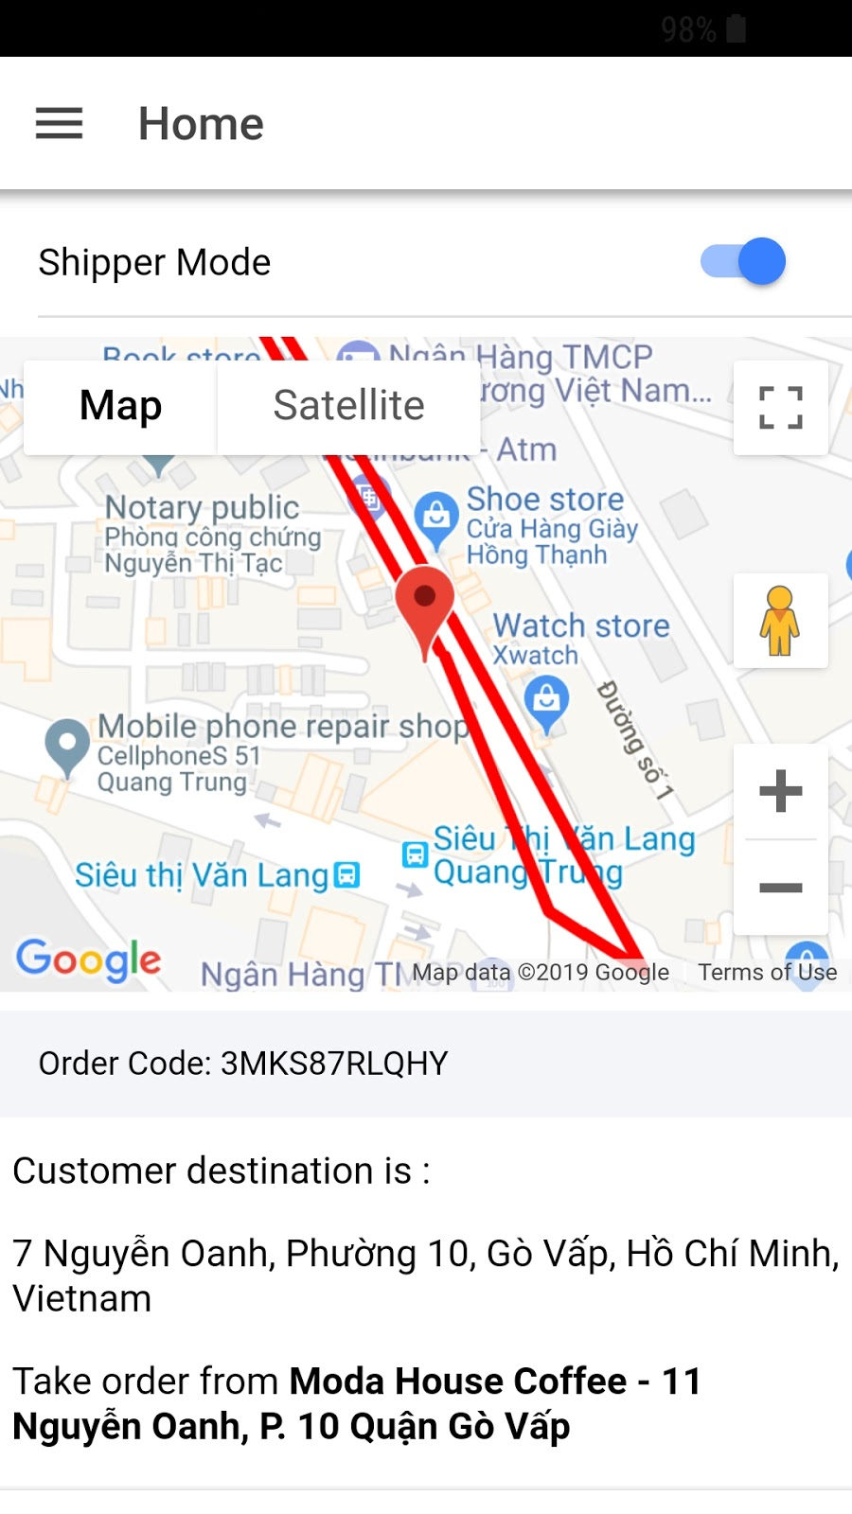

1. Checkout

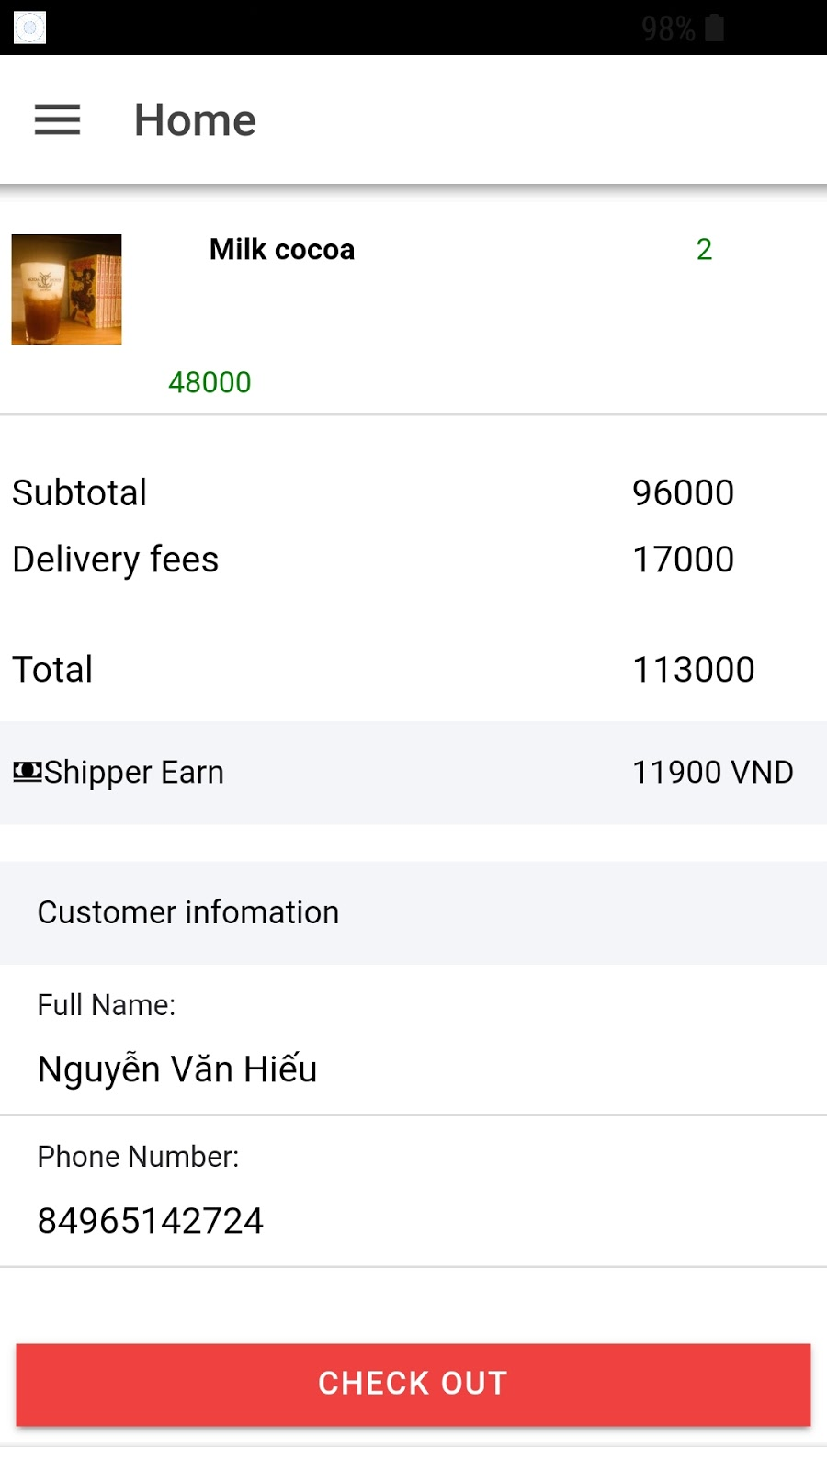

1. Edit Profile

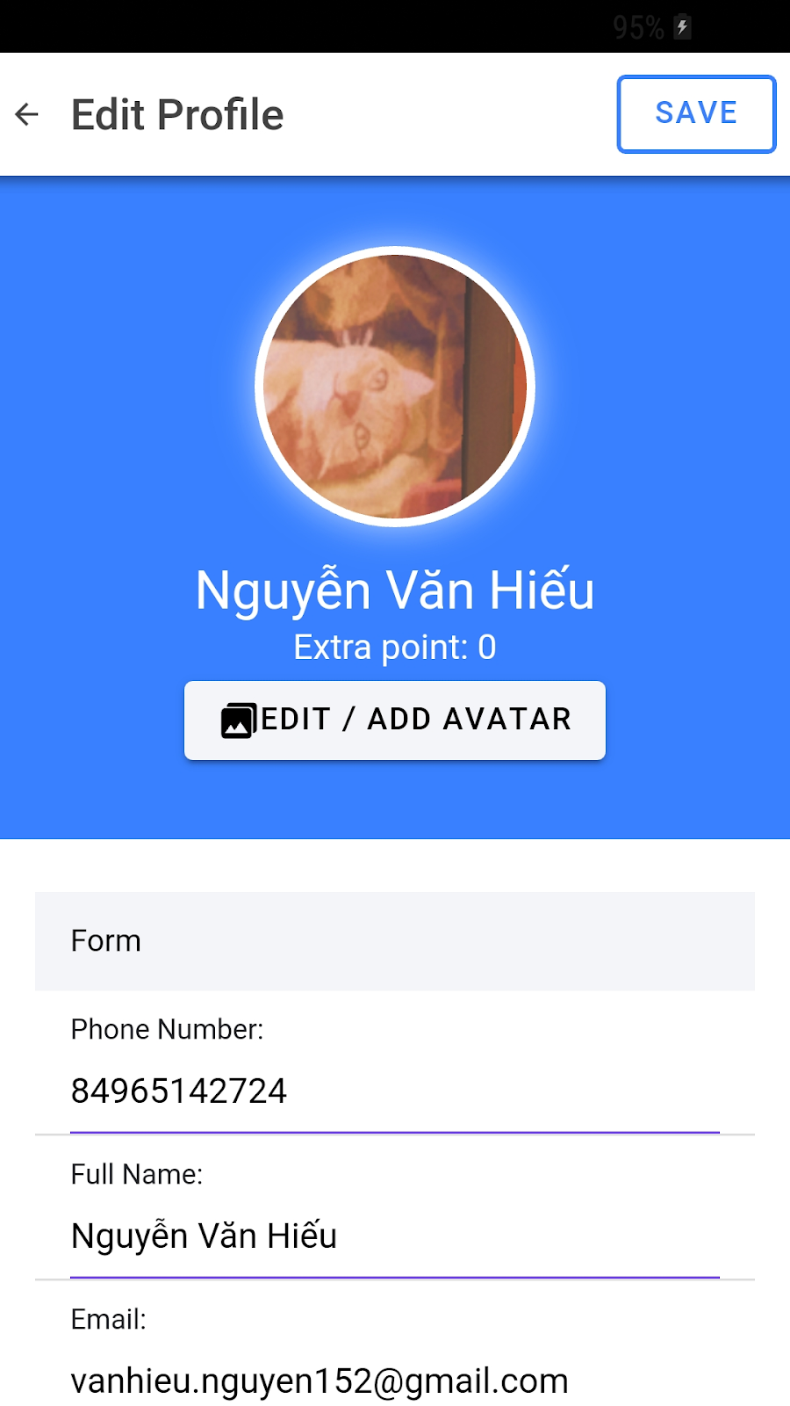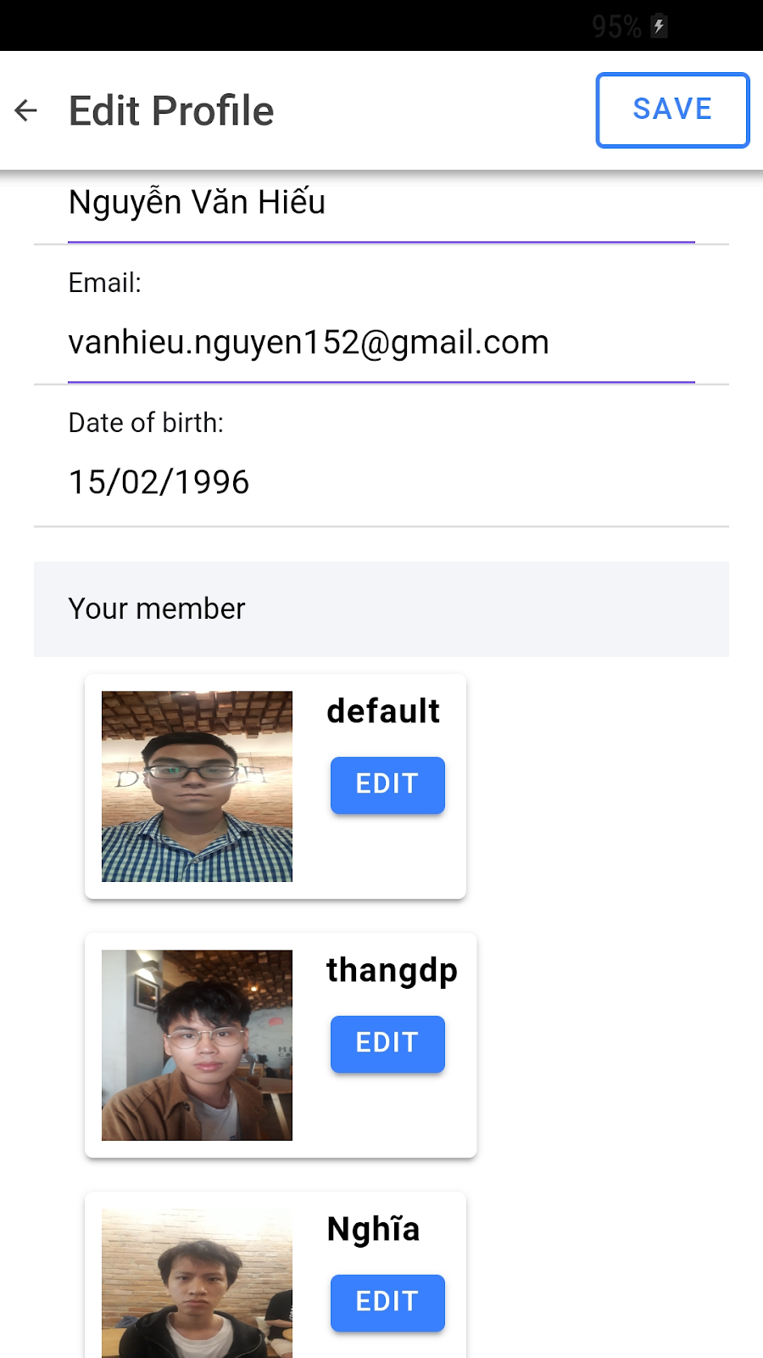

## 5.3 Admin Web Application

1. Login

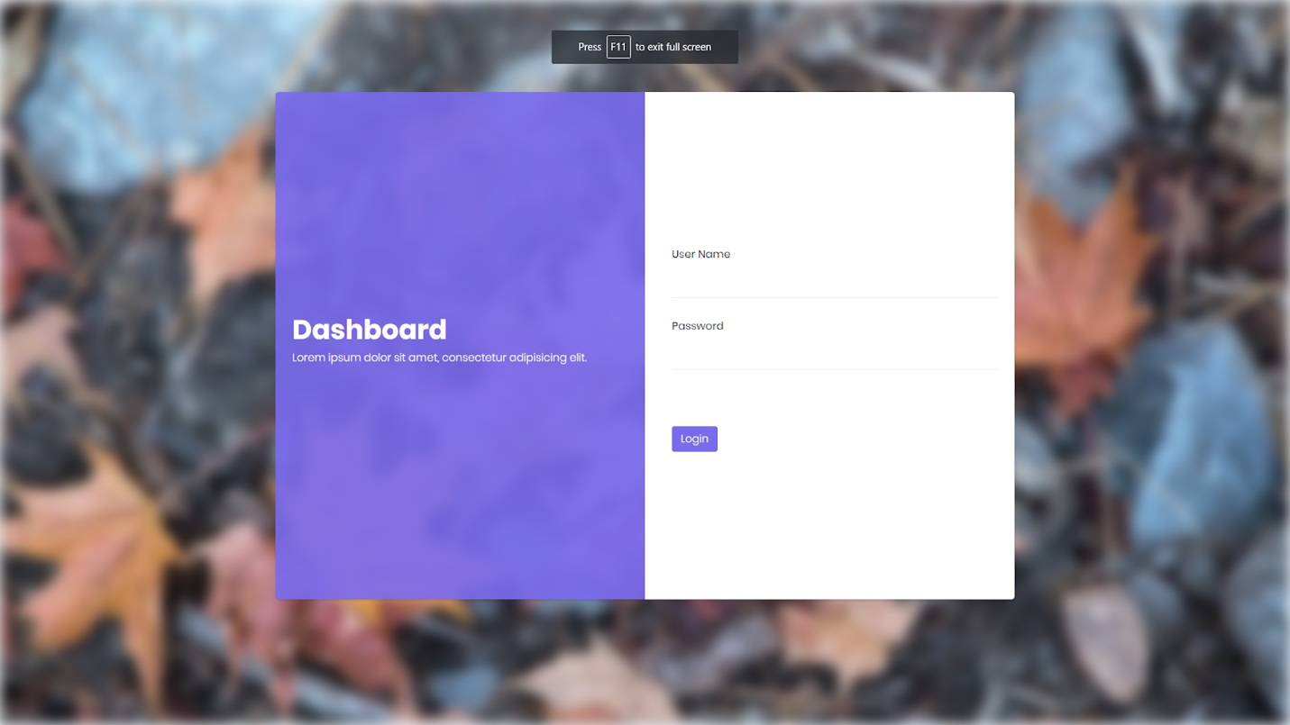

1. Edit Profile

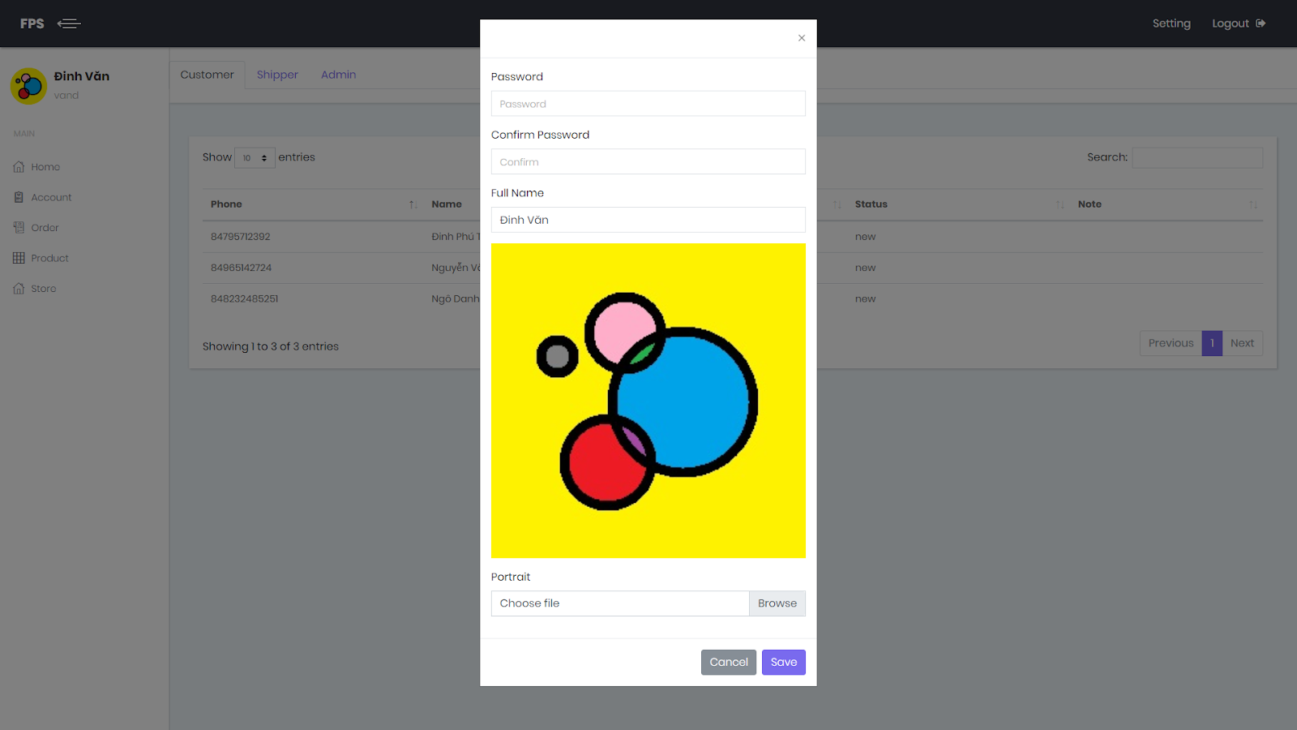

1. Manage Customer

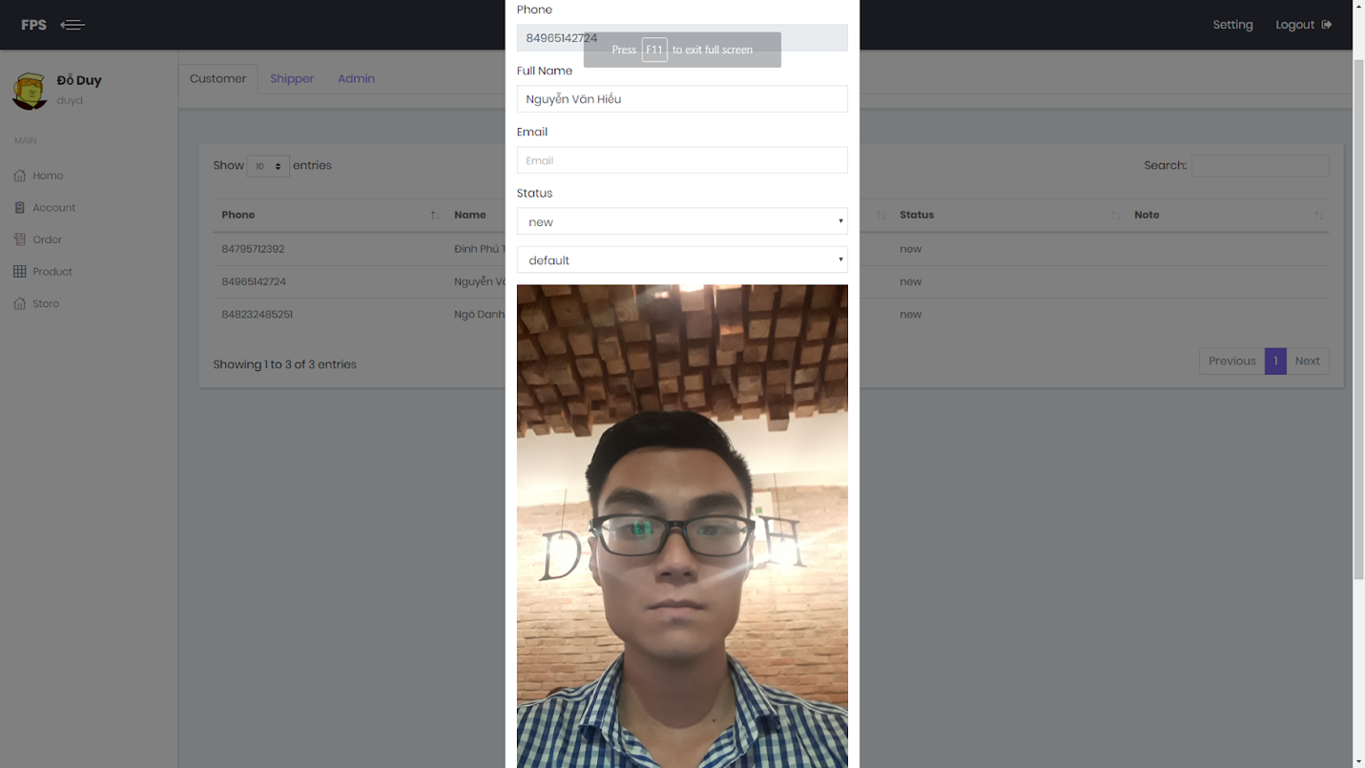

1. Manage Shipper

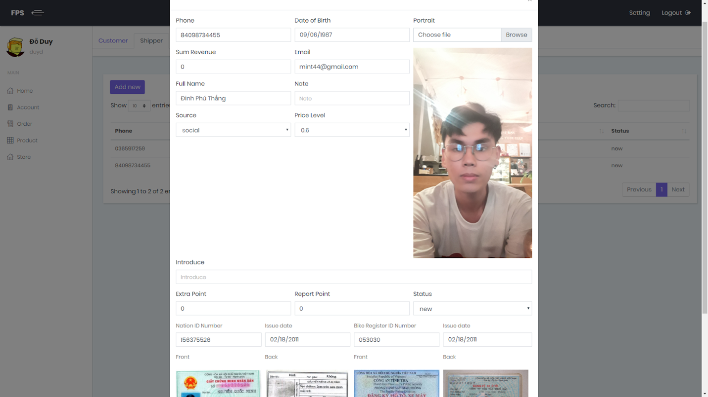

1. Manage Admin

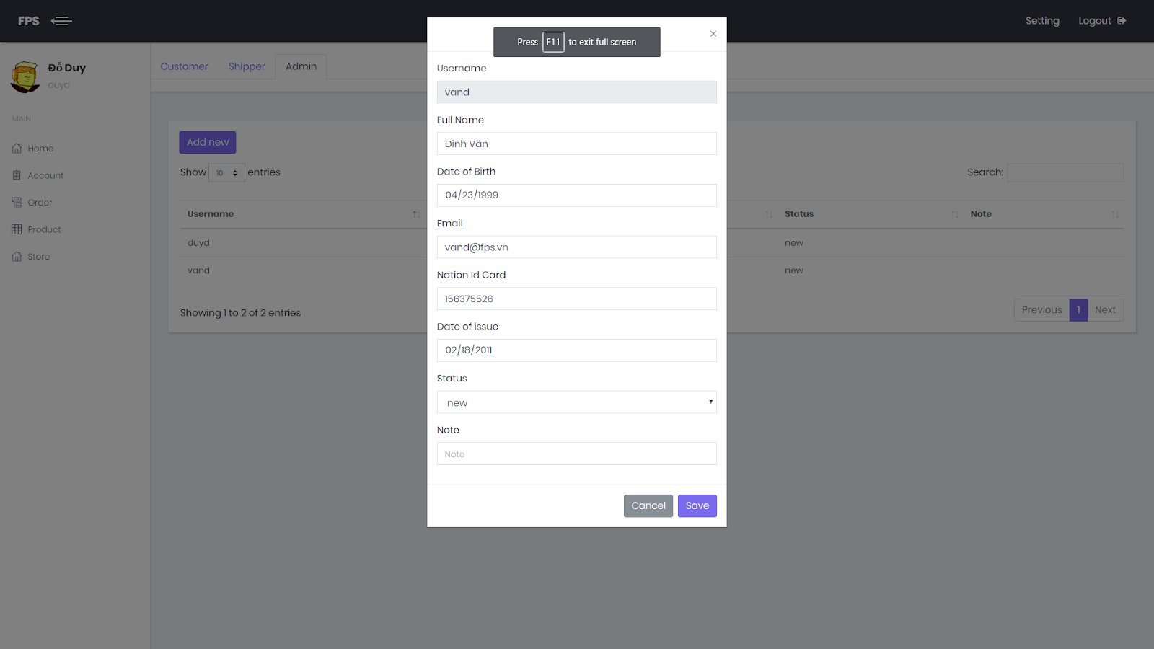

1. Manage Order

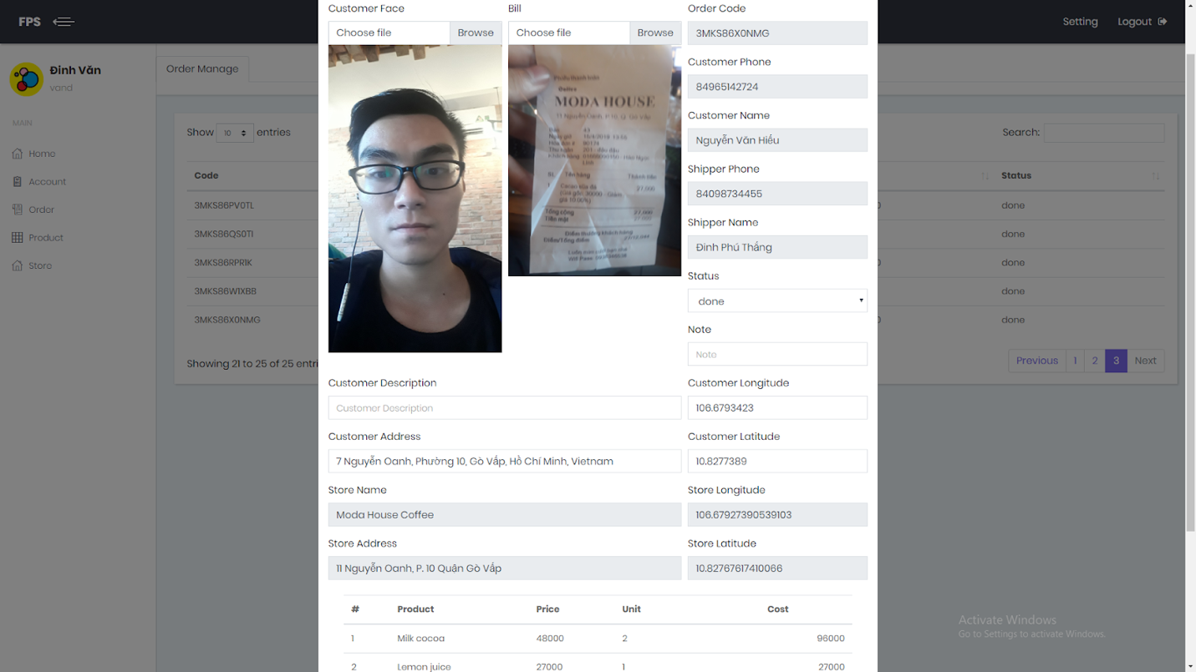

1. Manage Product

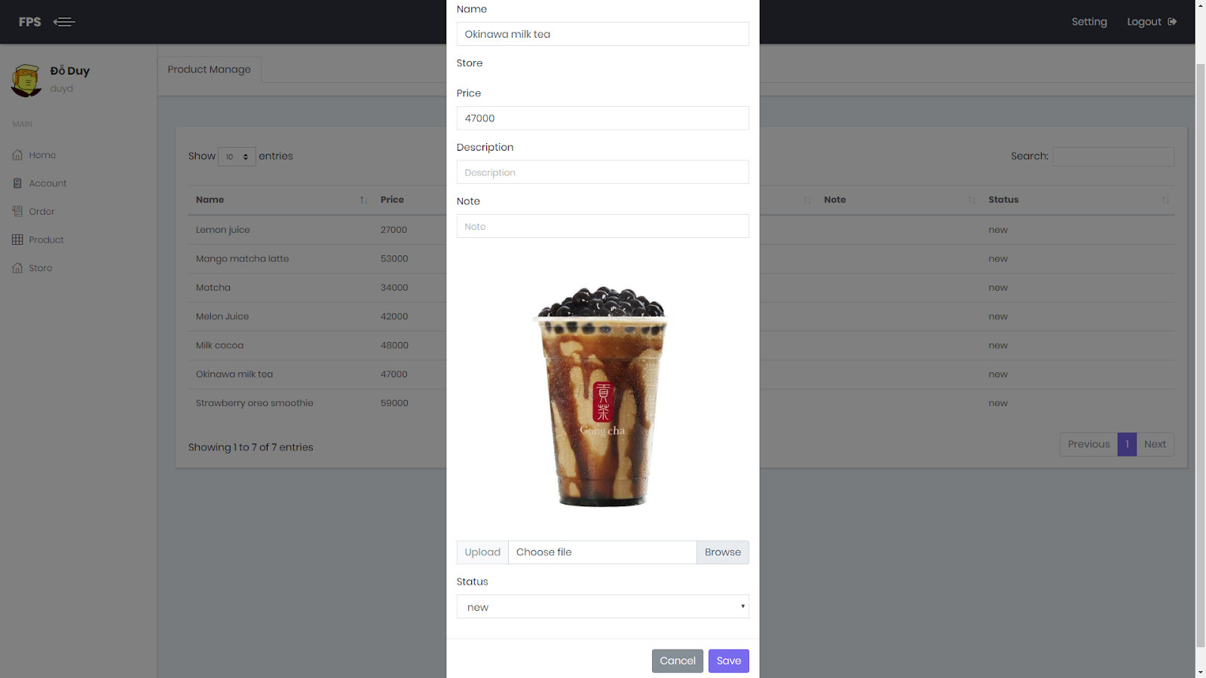

1. Manage Store

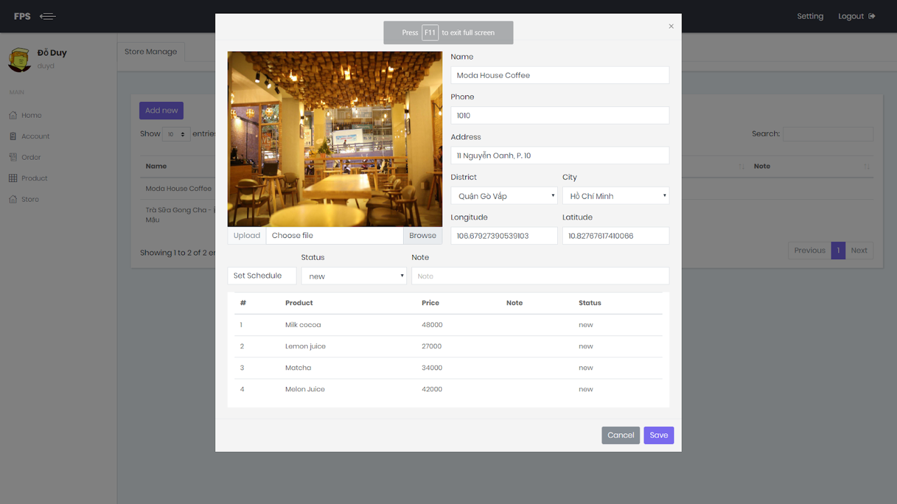

1. Manage Report and Static

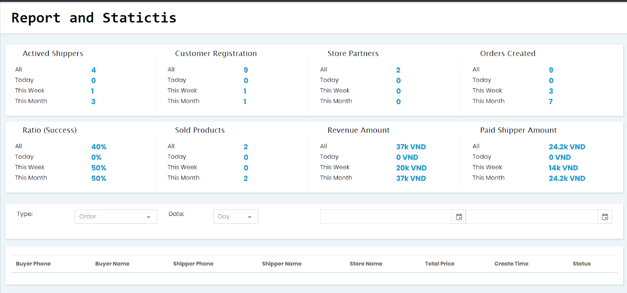

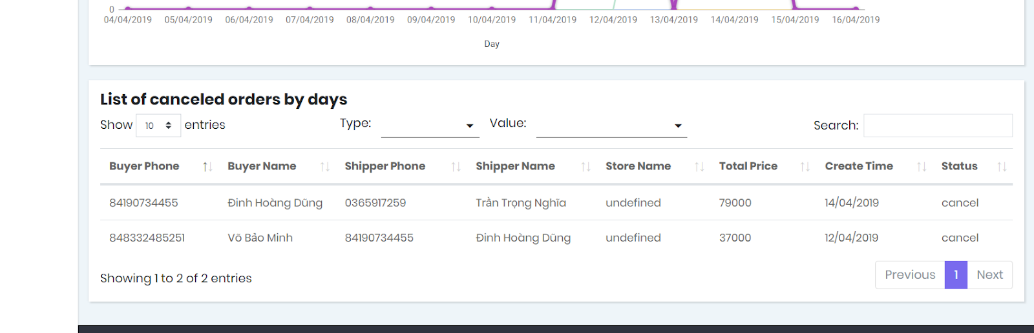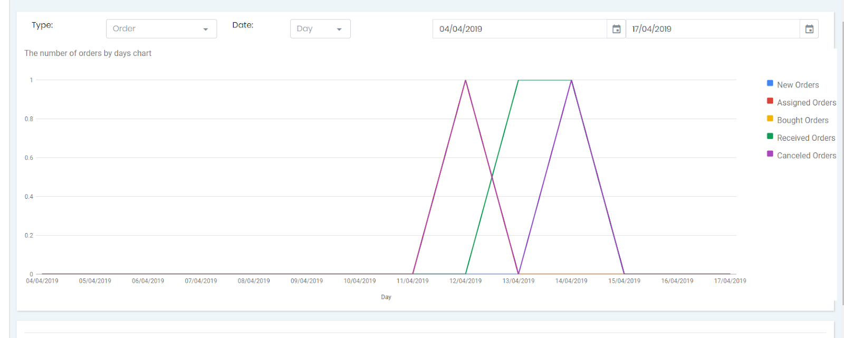

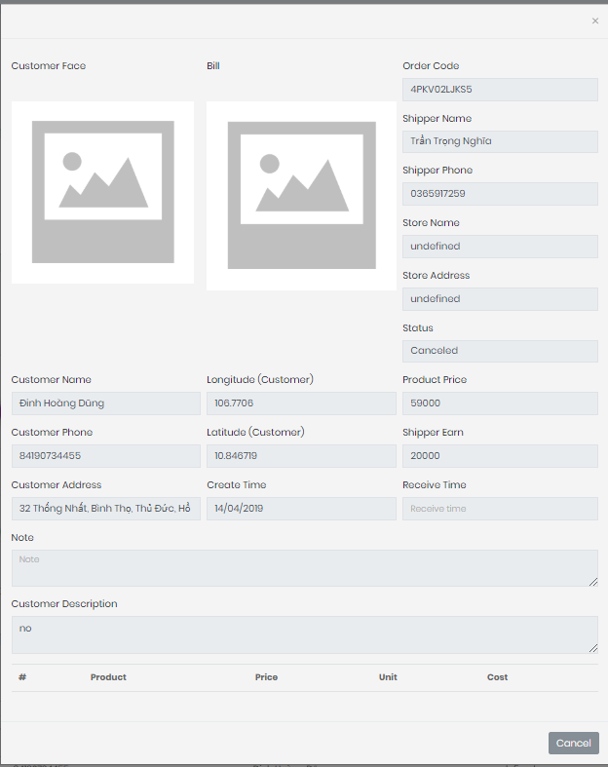

**6. Database Design**

**6.1 Physical Diagram**

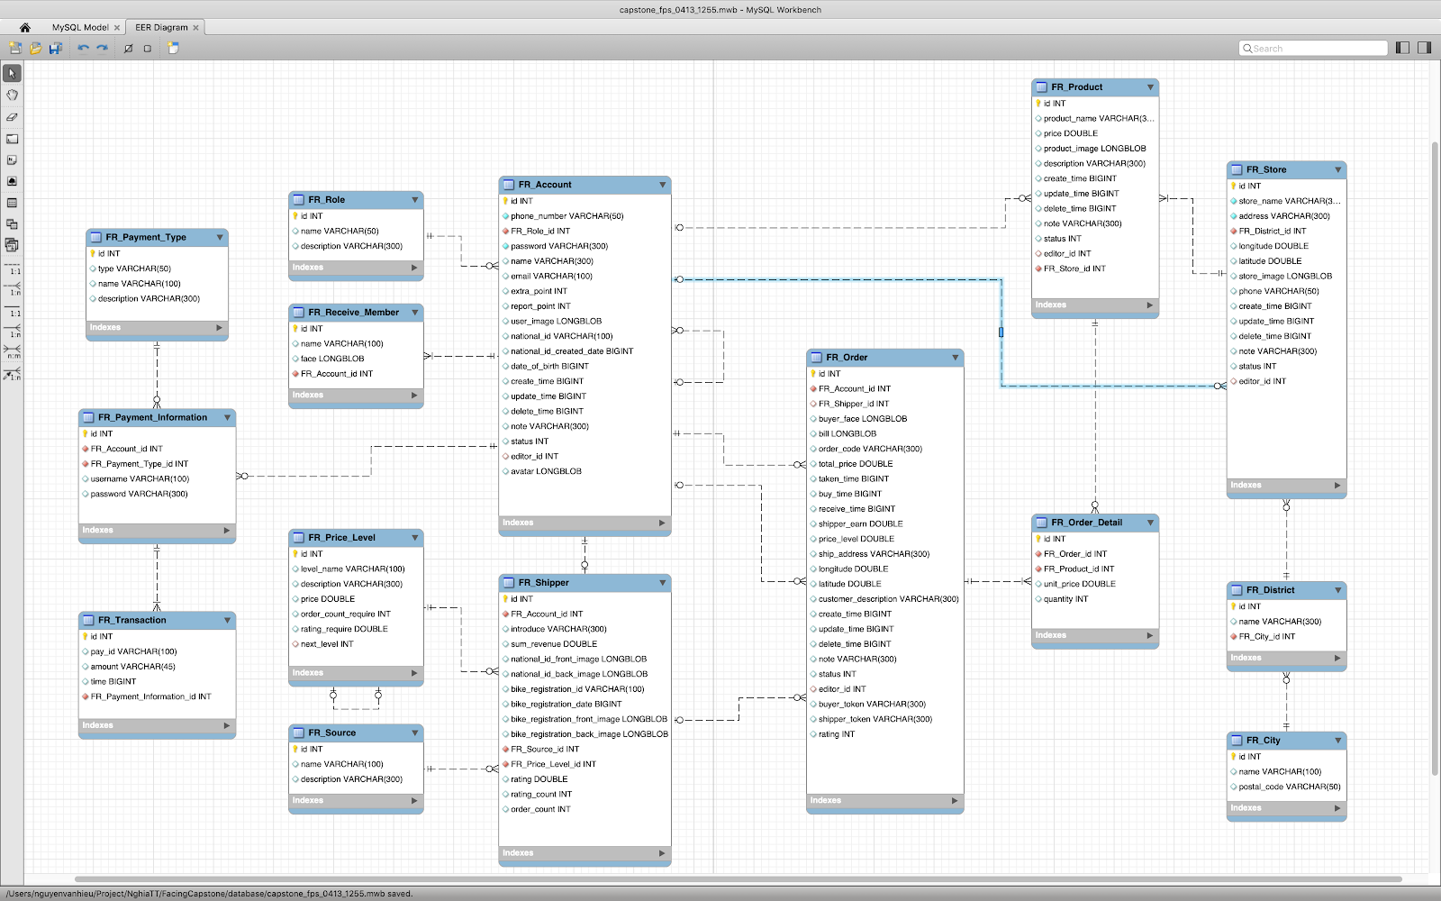

*Figure  Physical  Diagram*

## 6.2 Data Dictionary

|  |  |  |
| --- | --- | --- |
| **Entity Data Dictionary: Describe content of all tables** | | |
| **No.** | **Table Name** | **Description** |
| 1 | fr_account | Contain account information |
| 2 | fr_receive_member | Contain receive member information |
| 3 | fr_city | Contain city information |
| 4 | fr_district | Contain district data of city |
| 5 | fr_order | Contain data of order’s list |
| 6 | fr_order_detail | Contain data of order |
| 7 | fr_payment_information | Contain data of payment |
| 8 | fr_payment_type | Type of payment |
| 9 | fr_price_level | Select price level for shipper |
| 10 | fr_product | Contain data of every product of store |
| 11 | fr_role | Contain data role of member |
| 12 | fr_shipper | Contain data of shipper |
| 13 | fr_source | Contain source of data |
| 14 | fr_store | Contain data of store |
| 15 | fr_transaction | Contain data of transaction |

*Table  Data Dictionary*

# 7. Algorithms:

- Auto assign order for shipper.

- Keep data on client side (web admin).

- Paypal emulator.

- Hashing.

- Training Face System.

- Delivery Fee calculate.

- Shipper rating calculate.